Auditing the police:
Experimental evidence of racial disparities in police accountability *
Garrett Olson Stanford
Department of Finance, University of Oregon
Eugene, OR 97401
gos@uoregon.edu
March 2026

Abstract
I conduct a randomized controlled trial to causally test allegations that police in the U.S. struggle with equity and accountability. I email requests for assistance in making a complaint against an officer to over 2,000 police departments while manipulating the names of the fictitious complainant. I compare response rates according to the complainant’s race/ethnicity and gender. Departments were significantly less likely to respond to Black or Hispanic names than White names. White men received the highest response rate, and Black and Hispanic men the lowest. Results support the allegations that policing suffers from issues of bias and accountability.

*This study was preregistered with the AEA RCT registry: AEARCTR-0009233. The pre-analysis plan can be found here.

Introduction

Trust in the police reached a record low in the United States in 2020 and was accompanied by widespread calls for police reform (Brenan, 2020). Distrust was particularly pronounced among Black Americans, reflecting long-standing convictions that policing practices in the United States are, both historically and presently, shaped by racial discrimination (Hurwitz and Peffley, 2005; Jones, 2020). Police are more likely to target people of color for surveillance, vehicle stops, traffic citations, and asset forfeitures (Bulman, 2019; Chen et al., 2021; Gelman et al., 2007; Goncalves and Mello, 2021; Makowsky et al., 2019; Pierson et al., 2020; Sances and You, 2017; West, 2018). Furthermore, during interactions with people of color, police are more likely to use physical force (Edwards et al., 2019; Fryer, 2019; Nix et al., 2017; Ross, 2015). The disproportionate costs to people of color because of biased policing are significant and can impact almost every facet of their lives, beyond the immediate potential for physical violence and financial burdens of a police-civilian encounter (Graham et al., 2020; Kramer and Remster, 2022; Tebes and Fagan, 2022).
Both police accountability and the elimination of bias are central objectives of contemporary police reform. Yet the intersection of these two domains—how bias affects mechanisms of accountability—remains relatively understudied (Archbold, 2021; Engel et al., 2020; Mancini et al., 2023). To date, much of the research on accountability has focused on the effects of body-worn cameras (BWCs), with several studies concluding that BWCs reduce both citizen complaints and biased policing practices (Cubukcu et al., 2023; Huff et al., 2022; Lum et al., 2019; Voigt et al., 2017). However, accountability mechanisms beyond BWCs, particularly civilian-initiated complaints, have received far less attention.
Civilian complaints are one of the few avenues through which members of the public can directly hold police accountable and have the potential to deter biased policing by imposing consequences for discriminatory behavior (e.g., Rozema and Schanzenbach, 2023). Civilian complaints are intended to both document officer misconduct and provide a mechanism for accountability. Disciplinary action against officers engaging in biased policing may reinforce public perceptions of oversight and potentially reduce discriminatory practices. Effective complaint processes can be evaluated in terms of procedural justice—fairness in how complaints are filed and handled—and distributive justice—fairness in the outcomes of those complaints.
Existing research on civilian oversight often centers on the latter, examining bias in complaint outcomes (e.g., Headley et al., 2020; Liederbach et al., 2007; Mrozla, 2021; Stroube, 2021; Wright, 2020). While these studies are descriptively informative, they rarely permit causal inference and often overlook potential discrimination in earlier stages of the complaint process, such as the initial response to a civilian's attempt to file a complaint.
To address this gap, I use a correspondence study—a type of randomized controlled trial (RCT)—to causally test for bias in the first stage of the complaint process: the department’s response to an initial inquiry. I use fictitious civilian identities to email requests to 2,134 local U.S. police departments for assistance in making a complaint against an officer. These fictitious identities span three different apparent races/ethnicities (Black, Hispanic, and White) and two apparent genders (man and woman). I randomly vary which identity is assigned to contact a police department but control the remaining contents of the complaint inquiry. In this manner, I measure whether a civilian’s apparent race/ethnicity or gender affects the willingness of police departments to assist in holding their officers accountable.
I find evidence of bias in police response behavior. Police departments are considerably more likely to respond to emails signed with white-sounding names than emails signed with Black- or Hispanic-sounding names. The differences in response rates are even starker when race/ethnicity and gender are considered simultaneously. White men were the most likely to receive a response, while Black and Hispanic men were the least likely. Black, Hispanic, and white women fell in between. These findings suggest that racial and gender biases influence a critical early step in the accountability process and raise concerns about the procedural fairness of civilian oversight mechanisms.
Background

Research suggests that biased policing has broader downstream effects beyond immediate enforcement outcomes. Poor police-community relationships also affect the public’s willingness to cooperate with, assist, and ask for assistance from the police, which can compound existing issues with the provision of policing and trust in the police (e.g., McLean et al., 2024; Sunshine and Tyler, 2003).
For example, because people of color are less likely to call the police, they may have reduced access to the services police can provide (Brunson and Wade, 2019; Carr et al., 2007; Chalfin et al., 2022; Chenane et al., 2020; Owens and Ba, 2021). Strained relationships between the police and the local community can also exacerbate bias in policing, which then reinforces distrust of the police (Trinkner et al., 2019). Finally, because policing relies on cooperation from local communities, distrust may influence police-community interactions and overall effectiveness of law enforcement efforts, particularly for populations with existing skepticism toward the police.
Discrimination in the complaint process may influence trust between communities and local law enforcement agencies. Formal complaints are often one of the few ways a community member can hold a department accountable for abuse. An inequitable complaint process may contribute to disparities in other policing outcomes (e.g., excessive use of force or pretextual stops). In other words, the groups of people who are more likely to find themselves in a position warranting a formal complaint are less likely to be assisted in making such a complaint. Relatedly, differential accessibility of the complaint process may obscure the prevalence of misconduct in other aspects of policing.
Despite the increasing documentation of bias in various law enforcement contexts, research remains divided on the prevalence and severity of the problem (Fridell, 2017; Neil and Winship, 2019; Smith et al., 2017). This ambiguity is largely due to the difficulty of establishing causality in the context of biased policing. Several statistical challenges stand out. First is the issue of selection bias. Differences in the frequency of police interaction with different groups do not necessarily imply biased policing. Suppose sociodemographic groups participate in criminal activity at different frequencies. In this case, unbiased policing could still result in heterogeneous rates of police-civilian interactions across sociodemographic groups (Fridell, 2017; Neil and Winship, 2019). Second is the problem of conditioning on an outcome variable. Measuring biased policing by comparing outcomes for civilians conditional on an interaction with police can lead to a false conclusion that bias does not exist. Suppose the motivation for police initiating an interaction with a member of a particular sociodemographic group is biased, but outcomes for all police-civilian interactions are similar across groups. In that case, a naive analysis can obscure the presence of biased policing (Knox et al., 2020; Ross et al., 2018).
Finally, there are considerable data limitations when researching biased policing (Goff and Kahn, 2012). Leveraging observational data necessitates substantial assumptions. Consider the problem of comparing differences in sanctions for officers between White and Black complainants. One must assume that the reason for the interaction, the conduct during the interaction, and the actions taken by the complainant after the interaction are approximately identical. Furthermore, for a statistical comparison of formal complaint outcomes, all complaints must be filed to appear in the data, which could be a substantial obstacle (Ba, 2016). To further complicate the problem, intentionally or inadvertently, departments may not report or share accurate data (Luh, 2022). Moreover, police data can be a product of subjective reporting by individual police officers and department-specific classification conventions (Davidson and Madden, 2015; Policing Project, 2019). Finally, in instances where researchers do have access to a rich dataset and can establish a causal link convincingly, these data are often specific to a particular agency or municipality. Consequently, the results may not necessarily be generalizable to other departments or municipalities (Ba et al., 2021; Weisburst, 2019).
One way in which researchers navigate the methodological obstacles of causal research on police conduct is to run vignette studies. Vignette studies have been instrumental in improving the understanding of police behavior, particularly in the context of misconduct and procedural justice (see Nivette et al., 2024 for a review). Researchers have conducted vignette studies to assess how officer characteristics and demeanor can shape public perceptions of police legitimacy (e.g., Brown and Reisig, 2019, Johnson et al., 2017; Maguire et al., 2017; McClean, 2020; Solomon and Chenane, 2021; Wagner et al., 2017); how officers form suspicion (e.g., Phillips, 2009, 2020); and how officers perceive their peers’ misconduct (e.g., Foley, 2000; Klockars et al., 2000, 2004, 2006; Phillips 2010).
As a form of RCT, vignette studies are well suited for causal identification. Additionally, because researchers craft the scenarios presented to participants, these studies allow for the examination of questions that are difficult or impossible to address through other methods. However, several weaknesses limit their effectiveness (Nivette et al., 2024). Perhaps the most significant is that officers know they are participating in an experiment, which introduces concerns related to impression management, social desirability bias, hypothetical bias, and the “blue wall of silence” (e.g., Foley, 2000; Phillips, 2010). Moreover, due to feasibility constraints, vignette studies are often geographically limited to a small number of departments (e.g., Nix et al., 2017; Phillips, 2009).
This paper employs a different type of RCT: a correspondence study. Over the last decade, correspondence studies have become an increasingly popular tool for researchers who study discrimination (Bertrand and Duflo, 2017). In a correspondence study, individuals (often fictitious)—who are identical in terms of all observable characteristics other than the characteristic of interest—apply for a job, service, or good. The researcher then examines whether the experimentally varied characteristic of interest affects the outcome of the application or request.
Like vignette studies, correspondence studies help address key methodological challenges in police research. Unlike vignettes, however, they involve a degree of deception (i.e., officers do not know that they are part of a research experiment) which reduces the likelihood of response bias. This limited use of deception is generally considered ethically acceptable, as it poses minimal risk to participants and is critical to preserve the validity of the research. In this way, correspondence studies can complement the insights of vignette research by testing how officers behave in real-world contexts, rather than how they say they would respond to hypothetical ones.
Emulating the seminal work of (Bertrand and Mullainathan, 2004), researchers have used correspondence studies to identify a variety of types of discrimination (e.g., gender, age, or race) in various contexts (e.g., housing, medical services). However, with a few exceptions, the correspondence study literature has largely overlooked public services (Butler and Brockman, 2011; Einstein and Glick, 2017; Oberfield and Incantalupo, 2021; White et al., 2015).
The only prior correspondence study that includes law enforcement agencies is Giulietti et al. (2019). Giulietti et al. contact a wide range of public services (e.g., school districts, libraries, and tax agencies) with benign inquiries. Included in the study, are roughly 1,800 sheriff’s offices. The authors use racially distinctive male names (Black and white) and find that Black names receive fewer responses across the different types of agencies. These results provide foundational evidence that racial discrimination extends into the realm of basic local government services, not just private markets such as housing or employment.
The present study builds on these insights but differs along several key dimensions. Most importantly, while Giulietti et al. document racial bias in routine public service interactions, they do not examine police accountability mechanisms. By contacting local police departments with inquiries about filing complaints against officers, this study provides novel evidence on the fairness of the civilian complaint systems, and by extension, procedural justice and police accountability.
In addition to its focus on police accountability, this study makes two additional contributions. First, it expands the set of identities tested to include female and Hispanic names, allowing for an examination of gender-based discrimination and the intersection of gender and race/ethnicity. Second, it studies local police departments rather than sheriff’s offices. With over 10,000 departments, local police are the primary point of contact for many civilians, and studying these agencies provides critical insight into how discrimination and procedural fairness operate within law enforcement.
By using a correspondence study, I overcome some of the main challenges in studying discrimination in the context of law enforcement. First, I create a civilian-initiated police interaction that is not predicated on a crime taking place. Second, I designate my outcome of interest as the police department’s decision to interact with the potential complainant. Additionally, creating a novel data set of police-civilian interactions allows me to avoid potentially compromised self-reporting of data collected from (or provided by) law enforcement agencies.

Experiment

The objective of the study is to test whether the behavior of police departments exhibits racial/ethnic or gender discrimination when responding to requests for assistance in making a complaint against an officer. To conduct this study, I collected contact information for a nationwide sample of municipal police departments in the United States. Then, I emailed each department using one randomly assigned instance from a specially designed set of complainant “identities” I created. I fielded the experiment over a ten-week period, from late July 2022 to late August 2022. I sent roughly 210 emails each week, split across Monday, Tuesday, and Wednesday, at approximately 9 a.m. local time for each police department.
While emailing a police department may initially seem unconventional, it has become a common and legitimate means of civilian contact. Law enforcement agencies increasingly use electronic communication and social media platforms to engage with the public (Dawes, 2008; Hu and Lovrich, 2019; Kim et al., 2017; Lieberman et al., 2013). Email is often a practical first step for civilians seeking to file complaints, as in-person reporting can be burdensome or intimidating (Ba, 2020). Many departments provide online forms or send complaint materials electronically, underscoring the realism of this mode of communication. Moreover, research suggests that civilians are more likely to email government agencies when trust is low (Reddick, 2005), making this channel especially relevant to the study of police accountability.

Police department selection
The police departments included in this study are a stratified random sample. For inclusion in the study, I sampled only municipal police departments that are associated with a local government (i.e., I exclude state police; sheriffs; and special agencies, like airport, transit, and university police) and that serve a population of at least 7,500 people. Through my sampling process, I identified 2,134 local police departments with publicly available email addresses. The sample represents all U.S. states except Hawaii. Figure 1 describes how representative the resulting sample is at the state level. I use two metrics to illustrate the degree of representation: the proportion of the population contacted departments serve (top panel) and the share of departments eligible for this study I contacted (bottom panel).

Creation of fictitious identities
To signal the complainant’s putative race and gender to police departments, I use distinctive names and create email accounts associated with these names. This study includes six broad categories of identities: Black woman, Black man, Hispanic woman, Hispanic man, White woman, and White man. Sixty unique first-name/last-name combinations are specified for each type of identity. I select last names from the “Frequently Occurring Surnames in the 2010 Census” dataset. I select first names from previous research that identifies racially distinctive names (Gaddis, 2017a,b). I then create a unique email address for each last name used in the study (e.g., WhiteLastName@email.com). I also create a unique email address profile for each identity so that the full names of the identities are visible in the email inboxes of the police departments (e.g., Claire Olson <Olson@email.com>). The complete list of names can be viewed in Tables A.4 and A.3.

The email
Each department received one email from a single randomly assigned identity. All these emails are identical with two exceptions: (1) the identity of the email sender and (2) the sign-off used in the email. I randomly vary the sign-off across emails to test whether the tone of the email might affect police behavior. Figure 2 displays the email format.

Other data used
I use several additional datasets to identify police departments and to describe observable department characteristics (Kaplan, 2021; United States Department of Justice. Office of Justice Programs. Bureau of Justice Statistics, 2023; U.S. Census Bureau, 2019). These characteristics, ex-ante, seemed to be potentially relevant determinants of the response behaviors of police departments: numbers of officers and civilian employees for each department; county-level income information; and county-level racial/ethnic composition. Post-experiment, I examine how the demographic composition of police departments affects response rates. However, because these data are only available for a small subset of police departments, I cannot incorporate this dimension in the treatment assignment. After assigning treatment, I run a balance test to confirm that my treatment assignment is successfully randomized across the department characteristics.

Methodology
As is common with randomized controlled trials (RCT), the post-experiment analysis is relatively straight-forward. Given the random assignment of treatment across police departments, unobservable departmental characteristics are equally distributed across treatment arms. Consequently, any evidence of systematic differences in the response behavior of police departments across treatment arms can be plausibly attributed to a true causal effect.
In this study, I test whether the response behavior of police departments depends on the implied identity of an email sender. Specifically, I test whether police department response rates vary systematically across email sender identities. To this end, I estimate variations of the following equation:
1(Response_{i}) = β₁1(Race_{i} = Black) + β₂1(Race_{i} = Hispanic)
+ β₃1(Gender_{i} = Woman) + FE_{s,t} + ε_{i}

Where i indexes individual police departments, t indexes the week the email is sent, and s indexes a department’s state. The main outcome for this study, 1(Response_{i}), is a binary indicator for whether a police department responded, within four weeks, to an email (I record a response for a department if that department replies within 28 days). I did not record automatically generated emails from departments that merely acknowledged that the treatment email was received as a response. FE₍s, t) represents fixed effects for the week during which I sent the email and a department’s state. Given that I stratified the treatment assignment on week and state, I include fixed effects for both week and state throughout my analyses. Additionally, I cluster the standard errors by week and state.
The β s represent the percentage-point difference in response rates compared to the omitted identity group. The emphasis in this analysis concerns police agencies discriminating on race/ethnicity and gender. Accordingly, throughout the various analyses, I designate historically privileged groups (White, Man, or White Man) as the omitted group(s) in the estimation. A positive (negative) β coefficient for any other identity indicates that the average response rate was higher (lower) for that particular identity, compared to the omitted identity.

Results

Summary statistics
I attempted to contact 2,134 police departments. Table 1 summarizes the outcomes of these emails. My final analysis excludes the 48 undeliverable emails. The aggregate response rate is 66.22%, which marginally increases to 67.74% when I exclude the 48 undeliverable emails. A large majority of responses from police departments occurred during the first 24 hours after I sent the email, and I received 97% of the responses within two days. The timing of the responses suggests that the departments take the request for help seriously. Combining the aggregate response rate and response timing results paints a picture that not all departments are willing or able to assist the public in making a complaint against an officer. However, the departments that respond do so promptly.
In Table 2 Panel A, I report the summary statistics comparing police departments included in this study with police departments eligible for inclusion (municipal police departments serving populations of at least 7,500) but were not selected in my sampling. In Table 2 Panel B, I report the summary statistics comparing police departments that responded with departments that did not.

Pooled-identity Results
In the analysis, the outcome variable is a binary indicator for whether a police department responded—excluding automatically generated emails from departments merely acknowledging that the email was received. I use linear regressions to compare response rates across identities and designate either White, Men, or White men as the omitted category for the respective estimations. My analyses include state and week fixed effects throughout to accommodate the intentional week and state treatment stratification. I also cluster standard errors at the week and state level (Chaisemartin and Ramirez-Cuellar, 2024). Table 3 displays the percentage point differences in response rates when identities are aggregated for either race/ethnicity (Black, Hispanic, and white) or gender (man and woman).
I use two alternative weighting schemes to facilitate inference about different population parameters. The unweighted results reflect the response behavior of an average police department. In other words, if a person were to contact a randomly selected department, the unweighted estimates indicate their likely response. However, departments serving larger populations interact with more residents and are more likely to receive requests for assistance. By weighting each observation by the size of the department’s local population (i.e., the population of its jurisdiction), the estimates shift to reflect the expected experience of the average complainant rather than the average department.
Compared to the White email response rate of 75.62%, the response rates for Black and Hispanic emails were lower by -11.08 and -11.35 percentage points (pp) in the unweighted specification. These differentials are statistically significant at the 1% level. Estimates across weighting schemes are effectively identical for Black emails. Weighting by population marginally increases estimated response rate deficits for (i.e., discrimination against) Hispanic emails from -11.31 pp to -12.05 pp. I also compare department response rates for emails with any female identity to the mean response rate for emails with any male identity (66.41%). The unweighted estimate shows that females, on average, were 2.22 pp more likely to receive a response. However, the difference is not statistically significant. When weighted by population, the response rate difference between men and women shrinks to a noisily estimated zero.

Interacted Results
I now compare response rates across all six distinct identities. Research in other contexts has documented that the intersection of race/ethnicity and gender is an essential dimension of discrimination (Browne and Misra, 2003; Ifatunji and Harnois, 2016). There is also evidence that the intersectionality of race/ethnicity and gender also plays a significant role in the criminal justice system (Doerner and Demuth, 2009; Steffensmeier et al., 2017, 1998). To assess whether similar patterns emerge in this context of police responsiveness, I re-estimate the linear probability model including interaction terms between race, ethnicity, and gender. Table 4 presents the results.
In this specification, I designate the White man identity as the omitted (reference) category. This choice serves two purposes. First, it facilitates interpretation of the coefficients as differences relative to the group that, historically, has faced less discrimination compared to other groups (e.g., people of color or women). Second, White men exhibit the highest observed response rate in the data (76.67 percent), making them an empirically natural baseline for comparison.
Column (1) of Table 4 presents the unweighted model. Both Black and Hispanic men receive significantly fewer responses than White men, by 14.43 and 15.85 percentage points, respectively. These are the largest disparities across all identity groups. While Black and Hispanic women also receive fewer responses than White men (10.73 and 9.93 percentage points, respectively), the gender gap within each racial and ethnic group is notably smaller.
Column (2) reports estimates weighted by the local population characteristics of each police department. The magnitude of disparities generally increases, with the exception of Hispanic men. The estimated response rate gap between White men and Black men rises to 17.69 percentage points, the largest among all identities. The disparity for White women also increases to 6.07 percentage points, though it remains statistically insignificant.
These patterns suggest that the effects of race, ethnicity, and gender are not simply additive, but interact in meaningful ways. Across both unweighted and weighted models, Black and Hispanic women consistently receive higher response rates than their male counterparts, while White women consistently receive lower response rates than White men. Although these differences are not always statistically significant, the direction and consistency of the estimates indicate meaningful patterns consistent with intersectional dynamics. Notably, the lowest response rates are observed for Black and Hispanic men, while White men have the highest. Taken together, the findings indicate that White men are uniquely advantaged in this setting, while the gender hierarchy is reversed among Black and Hispanic identities, where women receive higher response rates than men.
These heterogeneous differences in response rates are consistent with intersectional discrimination. Analyzing race, ethnicity, or gender in isolation would obscure these patterns. A more nuanced, intersectional analysis reveals how these social categories combine to shape unequal treatment by public institutions.
Online complaint portal
Police departments, like many government institutions, are increasingly moving toward online modes of communication (Dawes, 2008; Hu and Lovrich, 2019; Kim et al., 2017; Lieberman et al., 2013). This includes both email and web-based contact or complaint forms. While collecting departmental email addresses for this study, I also recorded whether each department offered an online complaint submission portal. In total, I identified 270 departments with online complaint portals, representing approximately 13% of the study sample.
Table 5 presents response rate comparisons by race and ethnicity, stratified by whether the department maintains an online complaint portal. This analysis serves two purposes.
First, it functions as a robustness check. It is plausible that departments with online portals systematically deprioritize email communication, expecting civilians to use the web form instead. If so, differences in email response rates by race or ethnicity could be confounded by how identities are distributed across “portal” and “non-portal” departments. For this to meaningfully bias the results, two conditions must hold: (1) Black and Hispanic email inquiries would need to be disproportionately assigned to portal departments, and (2) those departments would need to be significantly less responsive overall. However, neither condition appears to hold in a meaningful way. Among portal departments, 96 emails were sent from Black-sounding names, 90 from Hispanic-sounding names, and 84 from White-sounding names—suggesting only minor variation. Similarly, the overall response rate for portal departments (66.7%) is only slightly lower than that for non-portal departments (67.9%). Comparing Model 1 (all departments) and Model 2 (non-portal departments), the estimated racial response rate gaps shrink modestly (1–2 pp) but the results remain substantively robust.
Second, this stratification offers insight into the role of discretion in shaping biased responsiveness. The racial and ethnic disparities in response rates appear larger among portal departments (Model 3), where police may feel less institutional pressure to respond. This result is primarily driven by a notably high response rate to White-sounding names (83%) in portal departments. Although the reason for this discrepancy is unclear, one explanation is that when left more to their own discretion, departments may exhibit greater racial bias in responsiveness. From an accountability standpoint, this pattern raises important questions about oversight and discretion in the complaint process. However, from a practical standpoint, if the departments that exhibit the greatest bias in favor of white-sounding names also provide accessible online complaint portals, the potential harm of their selective responsiveness may be partially mitigated by their additional online resources. That said, the relatively small number of portal departments (n = 270) warrants some caution in interpreting these results.

Mechanisms
The disparities in response rates strongly suggest that police departments consider the race/ethnicity of a civilian when contacted for help making a complaint. To better understand the mechanisms, I conduct a series of heterogeneity analyses based on county demographics and departmental characteristics. These tests help situate the findings in the standard discrimination framework (taste-based or statistical) and identify factors that exacerbate or mitigate disparities. While descriptive, these tests provide insight into institutional and community conditions that may inform policies aimed at reducing biased policing.
Community composition
I begin with county-level racial/ethnic composition using ACS 2019 data. I construct three measures: percent Black, percent Hispanic, and percent person of color (POC). Table 6 presents six models, with specifications both with and without county median income controls. Income controls are included to mitigate the possibility of conflating the effects of racial/ethnic composition with local economic welfare.
Results show that a larger share of Black residents is associated with lower response rates for Black email senders (16.6 pp, Model 1). After adding income controls, the disparity grows (62.1 pp, Model 2), suggesting the effect reflects taste-based rather than statistical discrimination. By contrast, no significant effects emerge for Hispanic senders. When I interact Black names with Hispanic population share (Model 3), I find a significant negative association, consistent with minority threat theory (Dollar, 2014), though this effect disappears once income is included. Overall, these results suggest that in counties with larger Black populations, departments respond less to Black complainants, which could be attributed to either statistical or taste-based discrimination. However, when I control for county-level income, the disparity increases, making a purely statistical explanation less likely and points more toward taste-based discrimination.
Department Characteristics
Next, I explore departmental features, including leadership and agency size. Research has found that congruence between civilians and law enforcement employees during an interaction can lead to more lenient or positive outcomes (e.g., Ba et al., 2021). Given the parameters of the present study, it is challenging to discern the race/ethnicity of the specific employee who receives the complaint email. However, I attempt to identify any possible relationship between law enforcement demographics and the differences in response rates across identities. Drawing on the 2016 and 2020 Law Enforcement Management and Administrative Survey (LEMAS), I examine how the demographic composition of a department’s chief correlate to response rates (United States Department of Justice, 2020; 2023).
Table 7 reports the results of interacting the race/ethnicity of the police chief and the identities. Coefficients are expressed relative to the omitted category of White complainants in departments with White chiefs. The results indicate that compared to white names, Black names are less likely to receive responses from departments with white Chiefs (-13.4pp). Conversely, Black names are more likely to receive a response than white names when the chief is Black (-13.4 + 31.8 = 18.4 pp). No significant effects appear for Hispanic chiefs. These results indicate that leadership identity shapes differential responsiveness along racial lines, consistent with patterns of in-group preference and organizational taste-based bias (e.g., Ba et al., 2021; West, 2018).
I also test whether the size of departments (measured by number of officers) affects disparities in response rates across identities. There are several plausible avenues in which departmental characteristics could impact response behavior. For example, larger departments may be more accustomed to complaints or have more resources to address them. Conversely, larger departments may have fewer resources per civilian served or may receive a proportionally larger share of complaints than smaller departments.
To estimate the effect of department size on response rates, I used LEOKA data, which reports on the number of employees at an agency. I create two department size indicators. The first indicator is dictated by the median number of total employees for the departments included in the study to determine a department’s large/small size category (Dept. size). The second indicator is similar but reflects the median value of law enforcement employees divided by the local population (Dept. per capita). For both indicators, the variable equals one if the agency value is larger than the median. I report the results in Table 8.
Larger departments are somewhat more responsive to Hispanic names (+5.8 pp, Model 1), but this effect disappears when measured per capita (Model 2). No consistent effects emerge for Black senders. The results suggest that departmental resources, proxied for by number of officers, are not a significant factor in the response rate disparities. In other words, the disparities in response rates between races do not seem to be driven or related to staffing constraints.
To more directly analyze whether departments’ civilian complaint statistics affect response rates, I use 2020 LEMAS data. I construct three measures: (1) whether a department received any complaint in 2020 (complaint_any); (2) the sustained complaint rate (complaint_sust_rate); and (3) complaints per officer (complaint_per_officer). Results are reported in Table 9.
Models 2 and 3 yield largely null findings. Model 1, however, shows that departments with at least one complaint in 2020 were 19.7 pp less likely to respond overall but 38.8 pp more likely to reply to Black-sounding names.
This pattern is consistent with prior work suggesting that scrutiny can produce “de-policing” (Shi, 2009; Rushin and Edwards, 2017), while also heightening attention to racial equity (Smith and Holmes, 2014). One interpretation is that accountability pressures reshape the form rather than the existence of bias: while departments under scrutiny respond less overall, they may consciously or unconsciously take steps to reduce the appearance of racial discrimination when they do reply. Whether this reflects shifts in statistical or taste-based shifts is unclear, but the results highlight how accountability can both suppress and redirect discriminatory behavior.
Finally, I consider whether the presence of a collective bargaining unit (CBU), which is often viewed as providing additional protections for officers, affects responsiveness (Dharmapala et al., 2022; Rushin, 2016). I create a sample for the CBU status of 568 departments using the 2016 LEMAS, administrative data from the Florida Department of Law Enforcement, and manually coded data from Rushin (2016). Shown in Table 10, CBU status appears to have no meaningful effect on racial disparities.
Complainant Characteristics
In addition to the race and gender of the email sender, I also varied the signoff and the implied age (see A.1.4. for an explanation). The signoff of the email does not affect response likelihood. However, age seems to mitigate discrimination. More specifically, “older” Black and Hispanic identities are more likely to receive a response than “younger” Black and Hispanic identities. This could be a sign of respect for the elderly, or perhaps departments interpret complaints from the elderly community differently.

Word Count and Response Time
The current analysis of the data from this correspondence study designates the outcome variable as a police department’s timely, non-automated response to a request for help. Consequently, the results are a coarse reflection of the average department’s willingness to respond to a civilian’s request for assistance in making a complaint about an officer. To understand better the quality of the responses, I analyze two additional dimensions of the response: (1) word count and (2) response time. I find that departments that respond do so quickly and that these responses are primarily under 100 words. I do not find that either of these response quality measures systematically vary according to the race or gender of the identities (please refer to Section A.3.4.).

Discussion
This study relies on two key features common to correspondence audits: distinctive names and email communication. Both dimensions warrant consideration, as they may influence the interpretation of the results and the extent to which the findings reflect bias in policing practices.
Research suggests racially distinctive names can be correlated with other characteristics, particularly socioeconomic status (SES) (Bertrand and Mullainathan, 2004; Elder and Hayes, 2023; Fryer and Levitt, 2004; Gaddis, 2017a). Fryer and Levitt (2004) find that the relationship between racially distinctive names and SES can operate within racial groups. More specifically, they show that among African Americans, distinctively Black names are likely to be given by lower-SES parents, so racially distinctive names may simultaneously signal both race and SES. In the context of the present study, distinguishing whether name effects stem from racial or socioeconomic cues may be conceptually useful but practically limited. Using race to infer socioeconomic traits (or vice versa) reflects a form of bias. Moreover, in the United States, race and SES are deeply intertwined (Hirschman and Garbes, 2021). Even if law enforcement agencies were to discriminate based on perceived SES, this “colorblind” form of bias would still disproportionately disadvantage Black and Hispanic individuals (e.g., Feigenberg and Miller, 2021b). Still, I test whether within-race SES status effects response rates but find no supporting evidence that this is the case.
Regarding email communication, in contrast with a phone call or face-to-face encounter, written communication allows time for a department to reflect before responding (Dube et al., 2025). Additionally, a department was only eligible for inclusion in this study if it had a publicly available email address, which 10% of departments did not. Departments that publicize email addresses may differ systematically from those that do not, a possibility explored in Table A.2 of the Appendix. Consequently, while email contact is increasingly common in modern policing and represents an important measure of how police departments interact with members of the public, this study’s results may represent a conservative estimate of discrimination.
These findings have several implications. First, biased responsiveness in the complaint process undermines procedural justice and public confidence in police accountability (e.g., Chan et al., 2023; Tyler, 1990; Tyler and Huo, 2002). If marginalized groups encounter barriers even in initiating complaints, this may contribute to the persistent racial gap in sustained complaints documented elsewhere (e.g., Liederbach et al., 2007; Mrozla, 2021). Second, because sustained complaints have been shown to deter future misconduct (Rozema and Schanzenbach, 2023), even modest differences in complaint initiation could produce meaningful downstream effects on police behavior (Goncalves and Mello, 2021; Terrill and Ingram, 2016; Rozema and Schanzenbach, 2019). Finally, the study demonstrates that correspondence audits can serve as a practical and scalable tool for measuring institutional bias in policing—a domain where credible causal evidence remains limited.
Future work could extend this framework to other stages of the accountability process or to other forms of contact with law enforcement (e.g., employment or service requests). Longitudinal or repeated audits could help identify departments that systematically underperform, providing evidence for targeted interventions (Kline and Walters, 2021). Providing feedback to such departments, shown in prior research to alter behavior (Parker et al., 2024), could represent one such intervention.
This study represents the first nationwide correspondence audit of local police departments in the United States and provides causal evidence of racial and gender disparities in the citizen complaint process. The results of this study offer empirical guidance for policymakers and practitioners seeking to understand and address inequities in police accountability.

Tables & Figures

Figure 1: The proportion of state populations represented by contacted police departments

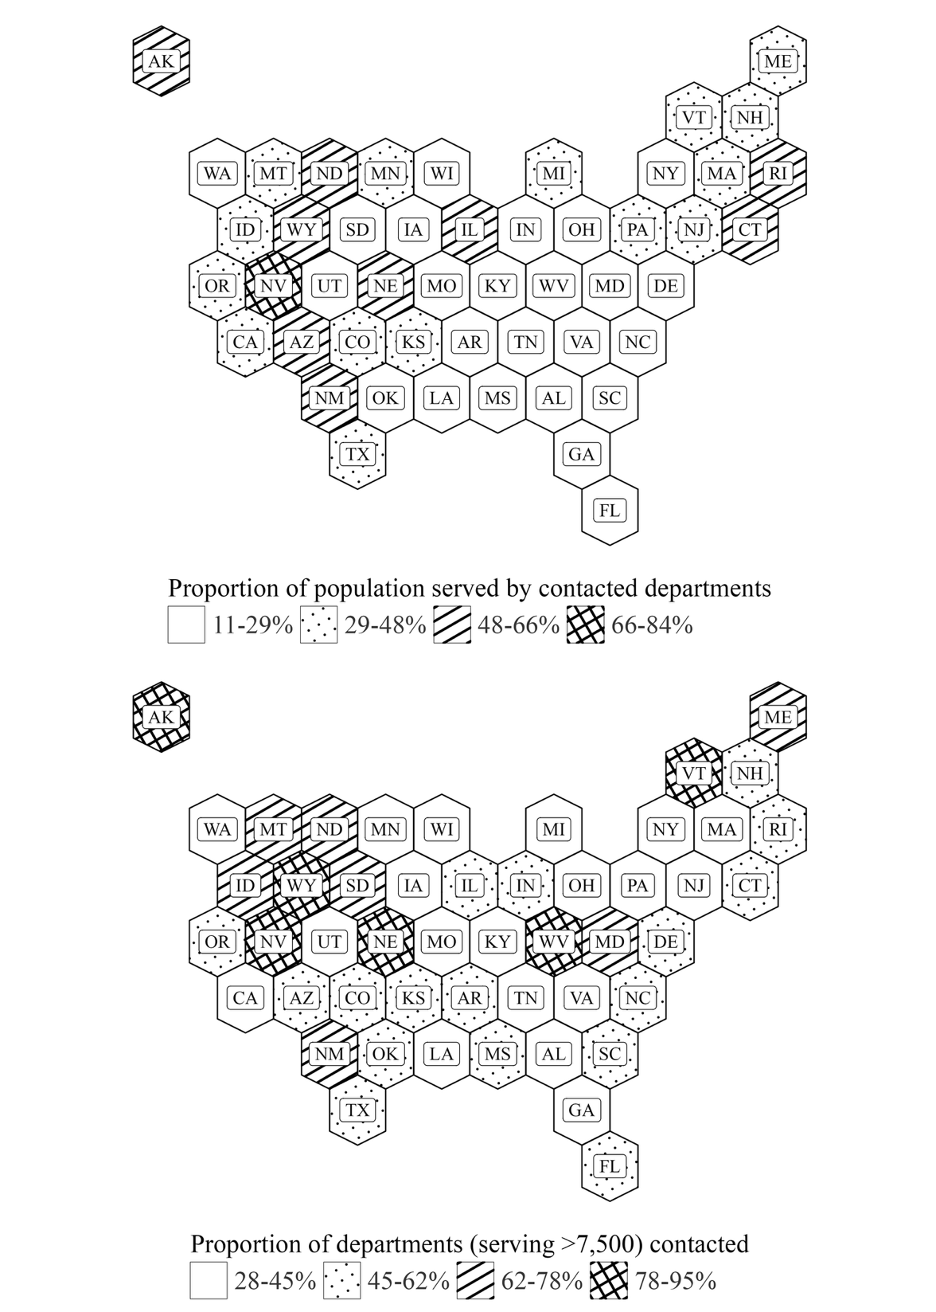

The figure shows representativeness of contacted local6police departments: the proportion of state population served (top) and the proportion of each state’s local police departments serving populations >7,500 (bottom).

Figure 2: Format of the email sent to police departments
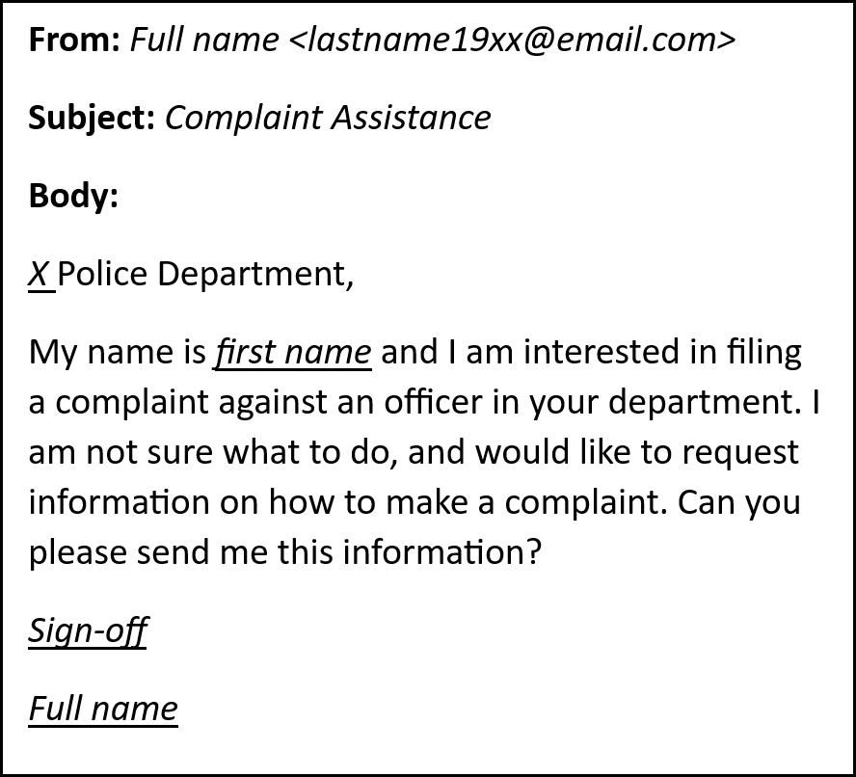

Every police department received a single email with nearly identical text. I randomly assigned an identity to each department and then signaled the race/ethnicity and gender of the identity using distinctive names. The assigned combinations of the name were shown three times for each email. I also randomly assigned one of two sign-offs to each email: “Thank you!” and “Sincerely,” to add a degree of warm/cool sentiment to the message.

Table 1: Summary statistics for the outcome of sent emails

Email Outcome | Total | Percent of Total
Single Response | 1,224 | 57.36%
Multiple Response | 189 | 8.86%
No Response | 673 | 31.54%
Denied | 13 | 0.61%
Failed | 35 | 1.64%
Sent | 2,134 | 100.00%
I categorize each email by its outcome. The results show an overall response rate of 66.22% (57.45 + 8.86). Forty- eight emails were undelivered because the police depart- ment’s address was incorrect/outdated (failed) or police departments blocked the emails (denied). The response is slightly higher (67.74%) if I drop the 48 undeliverable emails from the calculation. Of the 1,41 departments that responded, 189 departments sent multiple emails.

Table 2: Department summary stats for (A) contacted vs. uncontacted & (B) responsive vs. nonresponsive

 |  | Panel A |  |  |  |  |  | Panel B
 | Contacted | Uncontacted |  |  |  |  | Responsive | Unresponsive
 | Mean |  | Mean |  | Difference |  | Mean |  | Mean |  | Difference
Income (county-level)  Median income all HH ($1,000s) | 66.63 |  | 68.07 |  | -1.15 (0.54) |  | 67.74 |  | 64.26 |  | 3.48 (0.82)
Median income Black HH ($1,000s) | 47.68 |  | 48.02 |  | -0.35 (0.57) |  | 48.40 |  | 46.08 |  | 2.32 (0.92)
Median income Hispanic HH ($1,000s) | 52.91 |  | 53.55 |  | -0.49 (0.41) |  | 53.53 |  | 51.63 |  | 1.9 (0.65)
Median income White HH ($1,000s) | 73.62 |  | 75.53 |  | -1.48 (0.58) |  | 74.69 |  | 71.30 |  | 3.4 (0.9)
% Pop. in poverty | 12.19 |  | 12.19 |  | -0.04 (0.14) |  | 11.81 |  | 12.94 |  | -1.13 (0.22)
% Black pop. in poverty | 21.83 |  | 21.92 |  | -0.16 (0.29) |  | 21.64 |  | 22.17 |  | -0.53 (0.48)
% Hispanic pop. in poverty | 19.27 |  | 19.87 |  | -0.66 (0.23) |  | 19.08 |  | 19.58 |  | -0.51 (0.35)
% White pop. in poverty | 8.92 |  | 8.72 |  | 0.14 (0.1) |  | 8.67 |  | 9.42 |  | -0.75 (0.17)
Population  Local population (1000s) | 46.63 |  | 46.11 |  | 3.15 (5.27) |  | 49.59 |  | 51.28 |  | -1.69 (8.02)
Pop. % Black (county-level) | 10.21 |  | 10.68 |  | -0.38 (0.33) |  | 9.57 |  | 11.43 |  | -1.86 (0.52)
Pop. % Hispanic (county-level) | 14.01 |  | 15.42 |  | -1.02 (0.46) |  | 14.04 |  | 14.08 |  | -0.04 (0.69)
Pop. % White (county-level) | 68.27 |  | 65.85 |  | 1.91 (0.59) |  | 68.71 |  | 67.32 |  | 1.39 (0.92)
Department size (# of employees)  Total employees | 117.46 |  | 111.13 |  | 12.49 (25.24) |  | 119.66 |  | 142.64 |  | -22.98 (26.55)
Total officers | 93.66 |  | 85.44 |  | 13.12 (18.07) |  | 95.76 |  | 114.75 |  | -18.98 (22.39)
Total civilian employees | 23.80 |  | 25.69 |  | -0.62 (7.5) |  | 23.90 |  | 27.89 |  | -4 (4.76)
 | Proportion |  | Proportion |  | Difference |  | Proportion |  | Proportion |  | Difference
Census region  % Midwest | 29.85 |  | 27.53 |  | 2.32 |  | 30.86 |  | 27.49 |  | 3.37
% Northeast | 26.38 |  | 27.85 |  | -1.47 |  | 25.90 |  | 25.90 |  | -0.99
% South | 27.27 |  | 26.67 |  | 0.6 |  | 26.11 |  | 26.11 |  | -4.05
% West | 16.50 |  | 17.95 |  | -1.45 |  | 17.13 |  | 17.13 |  | 1.68
This table compares mean values of geographic and departmental characteristics. Panel A compares the police departments I contacted with all police departments eligible for inclusion in the study (i.e., municipal police departments serving populations ≥ 7,500). Panel B compares the departments that responded with the departments that did not respond. Column 2 reports the mean values for unique contacted departments (n= 2,127). Columns 3 and 4 report the mean for all eligible departments (n = 4,624) and the difference between the two populations (s.e. in parentheses). Similarly, Column 5 reports the mean values for responding departments (n = 1,413). Columns 6 and 7 report the mean for all contacted departments (n = 2,086) and the difference between responding and non-responding departments.

Table 3: Response Rate Differences by Race and Gender

 | (1) |  |  | (2)
 | Est. | p |  | Est. | p
Black | -0.1108 (0.0301) | 0.0050 |  | -0.1131 (0.0288) | 0.0035
Hispanic | -0.1135 (0.0264) | 0.0020 |  | -0.1205 (0.0177) | <0.0001
Women | 0.0222 (0.0301) | 0.4793 |  | 0.0029 (0.0302) | 0.9250
Weights | Standard OLS |  |  | Sqrt. local pop
Reference mean | White: 0.756
 | Men: 0.664
Num.Obs. | 2086 |  |  | 2086
I compare differences in response rates for races and genders, unweighted and weighted by local population. I report the estimates (standard errors) and p-values for each coefficient. Standard errors are clustered by state and week. Fixed effects are included for state and week. Black and Hispanic identities were less likely to receive responses from police departments than White identities. Black and Hispanic response rates were, respectively, 11.08 pp and 11.35 pp lower than the White response rate (75.6)—both significant at the 1% level. Women were marginally more likely, 2.22 pp, to receive responses than men (66.4).

Table 4: Response Rate Differences for Race and Gender Interactions

(1) |  | (2)
 | Est. | p |  | Est. | p
Black | -0.1443 (0.0366) | 0.0034 |  | -0.1769 (0.0456) | 0.0037
Hispanic | -0.1585 (0.0358) | 0.0017 |  | -0.1543 (0.0431) | 0.0060
Women | -0.0305 (0.0463) | 0.5275 |  | -0.0607 (0.0529) | 0.2805
Black women | 0.0675 (0.0474) | 0.1883 |  | 0.1248 (0.0637) | 0.0819
Hispanic women | 0.0896 (0.0296) | 0.0143 |  | 0.0667 (0.0440) | 0.1638
Weights | Standard OLS |  |  | Sqrt. local pop
Reference mean | White men 0.767
Num.Obs. | 2086 |  |  | 2086
Results display the difference in response rate for each identity compared to White men. I report the esti- mates (standard errors) and p-values for each coefficient. Standard errors are clustered by state and week. Fixed effects are included for state and week. The response rate for White men (76.7) is the highest, and I use it as the control group. Model 2 has the exact specifications as Model 1, but weights observations by the size of the local population for each department. Black and Hispanic Men were the least likely to receive responses from police departments. Black and Hispanic Women also have lower response rates than White men, but the magnitude of the estimates is not as large as that of their male counterparts. White women are less likely to receive responses than White men.

Table 5: Response rate differences for portal and non-portal departments

 | (1) |  |  | (2) |  |  | (3)
 | Est. | p |  | Est. | p |  | Est. | p
Black | -0.111 (0.030) | 0.005 |  | -0.096 (0.032) | 0.014 |  | -0.179 (0.090) | 0.077
Hispanic | -0.113 (0.026) | 0.002 |  | -0.094 (0.030) | 0.013 |  | -0.248 (0.065) | 0.004
Online portal use | All depts |  |  | No portal |  |  | Portal
Overall response rate | 0.677 |  |  | 0.679 |  |  | 0.667
Reference mean | White: 0.756 |  |  | White: 0.745 |  |  | White: 0.833
Num.Obs. | 2086 |  |  | 1816 |  |  | 270
Results show differences in response rates by race and ethnicity. Model 1 includes all departments. Model 2 restricts the sample to departments that do not have online complaint portals, while Model 3 includes only departments that do have online complaint portals. For each model, I report the overall response rate and the response rate for white-sounding names, which serve as the control group. Coefficient estimates are presented with standard errors in parentheses and p-values listed separately. All models include state and week fixed effects. Standard errors are clustered by state and week.

Table 6: Local population heterogeneity (race/ethnicity composition)

 | (1) |  |  | (2) |  |  | (3) |  |  | (4) |  |  | (5) |  |  | (6)
 | Est. | p |  | Est. | p |  | Est. | p |  | Est. | p |  | Est. | p |  | Est. | p
Black | -0.093 (0.018) | <0.001 |  | -0.048 (0.042) | 0.287 |  | -0.083 (0.029) | 0.018 |  | -0.104 (0.038) | 0.023 |  | -0.079 (0.032) | 0.037 |  | -0.043 (0.059) | 0.489
Pop% Black | -0.065 (0.137) | 0.643 |  | 0.847 (1375.257) | 1.000 |  | -0.195 (0.131) | 0.170 |  | 0.166 (1114.487) | 1.000
Hispanic | -0.127 (0.040) | 0.011 |  | -0.118 (0.068) | 0.117 |  | -0.135 (0.041) | 0.009 |  | -0.153 (0.055) | 0.022 |  | -0.134 (0.043) | 0.013 |  | -0.115 (0.091) | 0.236
Pop% Hispanic | -0.241 (0.081) | 0.016 |  | -0.158 (2324.659) | 1.000 |  | -0.133 (0.080) | 0.131 |  | -0.011 (1788.687) | 1.000
Black:Pop% Black | -0.166 (0.154) | 0.308 |  | -0.621 (0.237) | 0.028
Hispanic:Pop% Hispanic | 0.107 (0.149) | 0.492 |  | -0.020 (0.194) | 0.922
Black:Pop% Hispanic |  |  |  |  |  |  | -0.201 (0.061) | 0.009 |  | -0.072 (0.166) | 0.676
Hispanic:Pop% Black |  |  |  |  |  |  | 0.222 (0.204) | 0.304 |  | 0.295 (0.372) | 0.449
Pop% POC |  |  |  |  |  |  |  |  |  |  |  |  | -0.117 (0.088) | 0.216 |  | 0.585 (317.721) | 0.999
Black:Pop% POC |  |  |  |  |  |  |  |  |  |  |  |  | -0.099 (0.103) | 0.358 |  | -0.204 (0.123) | 0.132
Pop% POC:Hispanic |  |  |  |  |  |  |  |  |  |  |  |  | 0.066 (0.113) | 0.576 |  | -0.015 (0.148) | 0.919
Income controls | No |  |  | Yes |  |  | No |  |  | Yes |  |  | No |  |  | Yes
Num.Obs. | 2086 |  |  | 2086 |  |  | 2086 |  |  | 2086 |  |  | 2086 |  |  | 2086
Notes: This table reports how the response rates vary according to the racial/ethnic composition of the local population. Population data is at the county level. Even-numbered models include a fixed effect for median household income. POC (people of color) reflects all non-white peoples (i.e., 1- White population%). Standard errors are clustered by state and week. Fixed effects are included for state and week.

Table 7: Response rate differences by chief race and ethnicity

 | (1) |  |  | (2) |  |  | (3) |  |  | (4)
 | Est. | p |  | Est. | p |  | Est. | p |  | Est. | p
Black | -0.134 (0.049) | 0.023 |  | -0.195 (0.052) | 0.004 |  | 0.189 (0.121) | 0.153 |  | 0.270 (0.151) | 0.107
Chief Black | -0.173 (0.062) | 0.020 |  | -0.195 (0.038) | <0.001
Hispanic | -0.078 (0.059) | 0.220 |  | -0.088 (0.052) | 0.123 |  | -0.038 (0.095) | 0.700 |  | 0.028 (0.142) | 0.850
Chief Hispanic | 0.036 (0.102) | 0.732 |  | -0.010 (0.136) | 0.941
Black:Chief Black | 0.318 (0.133) | 0.040 |  | 0.452 (0.179) | 0.033
Hispanic:Chief Hispanic | -0.186 (0.152) | 0.254 |  | -0.159 (0.208) | 0.464
Chief White |  |  |  |  |  |  | 0.198 (0.062) | 0.011 |  | 0.242 (0.103) | 0.042
Black:Chief White |  |  |  |  |  |  | -0.332 (0.128) | 0.029 |  | -0.474 (0.173) | 0.023
Chief White:Hispanic |  |  |  |  |  |  | -0.058 (0.111) | 0.614 |  | -0.147 (0.169) | 0.409
LEMAS survey | Both |  |  | 2020 |  |  | Both |  |  | 2020
Num.Obs. | 724 |  |  | 491 |  |  | 727 |  |  | 494
Results show differences in response rates by race and ethnicity, interacted with the chief’s race. Data is drawn from LEMAS. Models 1 and 3 include data from the 2016 and 2020 LEMAS. Models 2 and 4 restrict the sample to the 2020 LEMAS data. For each model, I report the overall response rate and the response rate for white-sounding names, which serve as the control group. Coefficient estimates are presented with standard errors in parentheses and p-values listed separately. All models include state and week fixed effects. Standard errors are clustered by state and week.

Table 8: Department Size Heterogeneity (total employees)

 | (1) |  |  | (2)
 | Est. | p |  | Est. | p
Black | -0.102 (0.025) | 0.003 |  | -0.129 (0.040) | 0.011
Hispanic | -0.140 (0.036) | 0.003 |  | -0.118 (0.048) | 0.037
Dept. size | -0.001 (0.017) | 0.968
Black:Dept. size | -0.019 (0.051) | 0.720
Hispanic:Dept. size | 0.058 (0.026) | 0.049
Dept. per capita |  |  |  | -0.016 (0.039) | 0.682
Black:Dept. per capita |  |  |  | 0.033 (0.062) | 0.610
Hispanic:Dept. per capita |  |  |  | 0.015 (0.065) | 0.821
Num.Obs. | 2060 |  |  | 2060
Notes: I create a binary indicator for department size (Dept. size, dictated by the median department size (41 employees) and a binary indicator for department size per capita (Dept. size per dictated by the median per capita department size (total employees/served population: 0.0022). Twenty-six departments were dropped due to a lack of employee data. I compare response rates for each identity to the response rate for white names.

Table 9: Response rate differences by department complaint statistics

(1) |  | (2) |  |  | (3)
 | Est. | p |  | Est. | p |  | Est. | p
Black | -0.487 (0.136) | 0.006 |  | -0.142 (0.087) | 0.137 |  | -0.173 (0.038) | 0.001
Hispanic | -0.195 (0.217) | 0.394 |  | -0.163 (0.079) | 0.068 |  | -0.058 (0.052) | 0.291
complaint_any | -0.197 (0.076) | 0.029
Black:complaint_any | 0.388 (0.177) | 0.056
Hispanic:complaint_any | 0.109 (0.215) | 0.622
complaint_sust_rate |  |  |  | -0.193 (0.099) | 0.082
Black:complaint_sust_rate |  |  |  | 0.076 (0.256) | 0.772
Hispanic:complaint_sust_rate |  |  |  | 0.244 (0.180) | 0.207
complaint_per_officer |  |  |  |  |  |  | 0.036 (0.029) | 0.255
Black:complaint_per_officer |  |  |  |  |  |  | 0.134 (0.153) | 0.405
Hispanic:complaint_per_officer |  |  |  |  |  |  | -0.199 (0.175) | 0.285
LEMAS survey | 2020 |  |  | 2020 |  |  | 2020
Num.Obs. | 499 |  |  | 435 |  |  | 499
Results show differences in response rates by race and ethnicity, interacted with the complaint statistics for departments. Model 1 uses a binary indicator for whether a department received a complaint in 2020. Model 2 uses a sustained complaint rate: sustained complaint / (total complaints - pending complaints). Model 3 uses the average number of complaints per officer at a department. Data is drawn from the 2020 LEMAS. For each model, I report the overall response rate and the response rate for white-sounding names, which serve as the control group. Coefficient estimates are presented with standard errors in parentheses and p-values listed separately. All models include state and week fixed effects. Standard errors are clustered by state and week.

Table 10: Response rate differences by department collective bargaining unit status

 | Est. | p
Black | -0.014 (0.091) | 0.883
Hispanic | -0.002 (0.133) | 0.990
CBU | 0.009 (0.092) | 0.921
Black:CBU | -0.082 (0.106) | 0.459
Hispanic:CBU | -0.064 (0.152) | 0.684
Num.Obs. | 568
Results show differences in response rates by race and ethnicity, interacted with departments’ collective bargaining unit (CBU) status (i.e., whether a department has a CBU). I report the overall response rate and the response rate for white-sounding names, which serve as the control group. Coefficient estimates are presented with standard errors in parentheses and p-values listed separately. All models include state and week fixed effects. Standard errors are clustered by state and week.

References
Archbold, C. A. (2021). Police Accountability in the USA: Gaining Traction or Spinning Wheels? Policing: A Journal of Policy and Practice, 15(3):1665–1683.

Ba, B. (2016). How Far Are You Willing to Go against the Police? Evaluating the Effects of Citizen Affidavits in Chicago. dx.doi.org/10.2139/ssrn.2897063.

Ba, B. (2020). Going the extra mile: The cost of complaint filing, accountability, and law enforcement outcomes in Chicago.

Ba, B. A., Knox, D., Mummolo, J., and Rivera, R. (2021). The role of officer race and gender in police-civilian interactions in Chicago. Science, 371(6530):696–702.

Bertrand, M. and Duflo, E. (2017). "Chapter 8 - Field Experiments on Discrimination". In Handbook of Economic Field Experiments, volume 1, pages 309–393.

Bertrand, M. and Mullainathan, S. (2004). Are Emily and Greg More Employable than Lakisha and Jamal? A Field Experiment on Labor Market Discrimination. American Economic Review, 94(4):991– 1013.

Blickenstaff, J. C. (2005). Women and science careers: Leaky pipeline or gender filter? Gender and Education, 17(4), 369–386.

Brenan, M. (2020). Amid pandemic, confidence in key institutions surges. Gallup.

Brown, K. L., & Reisig, M. D. (2019). Procedural injustice, police legitimacy, and officer gender: A vignette-based test of the invariance thesis. Behavioral Sciences & the Law, 37(6), 696–710.

Browne, I. and Misra, J. (2003). The Intersection of Gender and Race in the Labor Market. Annual Review of Sociology, 29:487–513.

Brunson, R. K. and Wade, B. A. (2019). “oh hell no, we don’t talk to police”. Criminology and Public Policy, 18(3):623–648.

Bulman, G. (2019). Law Enforcement Leaders and the Racial Composition of Arrests. Economic Inquiry, 57(4):1842–1858.

Butler, D. M. and Broockman, D. E. (2011). Do politicians racially discriminate against constituents? A field experiment on state legislators. American Journal of Political Science, 55(3):463–477.

Carnes, M., Devine, P. G., Manwell, L. B., Byars-Winston, A., Fine, E., Ford, C. E., Forscher, P., Isaac, C., Kaatz, A., Magua, W., and Sheridan, J. (2015). The effect of an intervention to break the gender bias habit for faculty at one institution: a cluster randomized, controlled trial. Academic Medicine, 90(2), 221-230.

Carr, P. J., Napolitano, L., and Keating, J. (2007). We Never Call the Cops and Here is Why: A Qualitative Examination of Legal Cynicism in Three Philadelphia Neighborhoods*. Criminology, 45(2):445– 480.

Chaisemartin, C. d. and Ramirez-Cuellar, J. (2024). At What Level Should One Cluster Standard Errors in Paired and Small-Strata Experiments? American Economic Journal: Applied Economics, 16(1):193– 212.

Chalfin, A., Hansen, B., Weisburst, E. K., and Williams Jr., M. C. (2022). Police Force and Civilian Race. American Economic Review: Insights, 4(2):139–158.

Chan, A., Bradford, B., & Stott, C. (2023). A systematic review and meta-analysis of procedural justice and legitimacy in policing: the effect of social identity and social contexts. Journal of experimental criminology, 1-58.

Chen, M. K., Christensen, K. L., John, E., Owens, E., and Zhuo, Y. (2021). Smartphone Data Reveal Neighborhood-Level Racial Disparities in Police Presence. arXiv.2109.12491v2.
Chenane, J. L., Wright, E. M., and Gibson, C. L. (2020). Traffic stops, race, and perceptions of fairness. Policing and Society, 30(6):720–737.

Cubukcu, S., Sahin, N., Tekin, E., and Topalli, V. (2023). The Effect of Body-Worn Cameras on the Adjudication of Citizen Complaints of Police Misconduct. Justice Quarterly, 40(7):999–1023.

Davidson, C. and Madden, P. (2015). DC’s ‘assaulting an officer’ charge could hide police abuse, critics say. https://revealnews.org/article/dcs-assaulting-an-officer-charge-could-hide-police-abuse-critics-say/.

Dawes, S. S. (2008). The Evolution and Continuing Challenges of E-Governance. Public Administration Review, 68(s1):S86–S102.

Dharmapala, D., McAdams, R. H., and Rappaport J. (2022). Collective Bargaining Rights and Police Misconduct: Evidence from Florida, The Journal of Law, Economics, and Organizatio, 38(1):1-41.

DiPrete, T. A., & Eirich, G. M. (2006). Cumulative advantage as a mechanism for inequality: A review of theoretical and empirical developments. Annual Review of Sociology, 32(1), 271–297.

Dixon, T. L. (2008). Crime news and racialized beliefs: Understanding the relationship between local news viewing and perceptions of African Americans and crime. Journal of Communication, 58(1), 106–125.

Doerner, J. K. and Demuth, S. (2009). The Independent and Joint Effects of Race/Ethnicity, Gender, and Age on Sentencing Outcomes in U.S. Federal Courts. Justice Quarterly, 27(1):1–27.

Dollar, Cindy Brooks. (2014) Racial Threat Theory: Assessing the Evidence, Requesting
Redesign, Journal of Criminology,

Dube, O., MacArthur, S. J., and Shah, A. K. (2025). A Cognitive View of Policing*. The Quarterly Journal of Economics, 140(1):745–791.

Edwards, F., Lee, H., and Esposito, M. (2019). Risk of being killed by police use of force in the United States by age, race–ethnicity, and sex. Proceedings of the National Academy of Sciences of the United States of America, 116(34):16793–16798.

Einstein, K. L. and Glick, D. M. (2017). Does Race Affect Access to Government Services? An Experiment Exploring Street-Level Bureaucrats and Access to Public Housing. American Journal of Political Science, 61(1):100–116.

Elder, E. M. and Hayes, M. (2023). Signaling Race, Ethnicity, and Gender with Names: Challenges and Recommendations. The Journal of Politics, 85(2):764–770.

Engel, R. S., McManus, H. D., and Isaza, G. T. (2020). Moving beyond "Best Practice": Experiences in Police Reform and a Call for Evidence to Reduce Officer-Involved Shootings. The ANNALS of the American Academy of Political and Social Science, 687(1):146–165.

Faber, J. W. and Kalbfeld, J. R. (2019). Complaining While Black: Racial Disparities in the Adjudication of Complaints against the Police. City & Community, 18(3):1028–1067.

Feigenberg, B. and Miller, C. (2021a). Racial divisions and criminal justice: Evidence from southern state courts. American Economic Journal: Economic Policy, 13(2):207–240.

Feigenberg, B. and Miller, C. (2021b). Would Eliminating Racial Disparities in Motor Vehicle Searches have Efficiency Costs? The Quarterly Journal of Economics, 137(1):49–113.

Foley, M. O. (2000). Police perjury: A factorial survey [Ph.D., City University of New York].

Fridell, L. A. (2017). Explaining the Disparity in Results Across Studies Assessing Racial Disparity in Police Use of Force: A Research Note. American Journal of Criminal Justice, 42(3):502–513.

Fryer, R. G. (2019). An Empirical Analysis of Racial Differences in Police Use of Force. Journal of Political Economy, 127(3):1210–1261.

Fryer, Jr., R. G. and Levitt, S. D. (2004). The Causes and Consequences of Distinctively Black Names*. The Quarterly Journal of Economics, 119(3):767–805.

Gaddis, S. M. (2017)a). How Black Are Lakisha and Jamal? Racial Perceptions from Names Used in Correspondence Audit Studies. Sociological Science, 4:469–489.

Gaddis, S. M. (2017)b). Racial/Ethnic Perceptions from Hispanic Names: Selecting Names to Test for Discrimination. Socius, 3. doi.org/10.1177/2378023117737193.

Gelman, A., Fagan, J., and Kiss, A. (2007). An analysis of the new york city police department’s “stop- and-frisk” policy in the context of claims of racial bias. Journal of the American Statistical Association, 102(479):813–823.

Giulietti, C., Tonin, M., and Vlassopoulos, M. (2019). Racial discrimination in local public services: A field experiment in the United States. Journal of the European Economic Association, 17(1):165–204.

Goff, Phillip. A, and Barsamian, Kahn K. (2012). Racial Bias in Policing: Why We Know Less Than We Should. Social Issues and Policy Review, 6(1):177–210.

Goncalves, F. and Mello, S. (2021). A few bad apples? racial bias in policing. American Economic Review, 111(5):1406–1441.

Goodison, S. E. (2020). Local police departments, 2020. United States Department of Justice. Office of Justice Programs. Bureau of Justice Statistics.

Graham, A., Haner, M., Sloan, M. M., Cullen, F. T., Kulig, T. C., and Jonson, C. L. (2020). Race and Worrying About Police Brutality: The Hidden Injuries of Minority Status in America. Victims & Offenders, 15(5):549–573.

Headley, A. M., D’Alessio, S. J., and Stolzenberg, L. (2020). The Effect of a Complainant’s Race and Ethnicity on Dispositional Outcome in Police Misconduct Cases in Chicago. Race and Justice, 10(1):43–61.

Hirschman, D. and Garbes, L. (2021). Toward an economic sociology of race. Socio-Economic Review, 19(3):1171–1199.
Hu, X. and Lovrich, N. P. (2019). Social media and the police: A study of organizational characteristics associated with the use of social media. Policing: An International Journal, 42(4):654–670.

Huff, J. (2022a). Do body-worn cameras reduce disparities in police behavior in minority communities? Evidence of nuanced influences across Black and Hispanic neighborhoods. Criminology and PublicPolicy, 21:671–711.

Huff, J., Katz, C. M., and Hedberg, E. C. (2022b). A randomized controlled trial of the impact of body-worn camera activation on the outcomes of individual incidents. Journal of Experimental Criminology,18(2):247–272.

Hurwitz, J. and Peffley, M. (2005). Explaining the Great Racial Divide: Perceptions of Fairness in the U.S. Criminal Justice System. The Journal of Politics, 67(3):762–783.

Ifatunji, M. A. and Harnois, C. E. (2016). An Explanation for the Gender Gap in Perceptions of Discrimination among African Americans: Considering the Role of Gender Bias in Measurement. Sociology of Race and Ethnicity, 2(3):263–288.

Invisible Institute. "Complainants and Victims." Accessed August 28, 2025. https://invisible.institute/complaints-summary/complainants-and-victims

Johnson, D., Wilson ,David B., Maguire ,Edward R., & and Lowrey-Kinberg, B. V. (2017). Race and Perceptions of Police: Experimental Results on the Impact of Procedural (In)Justice. Justice Quarterly, 34(7), 1184–1212.

Jones, J. M. (2020). Black and white adults’ confidence diverges on police. Gallup.

Kaplan, J. (2021). Jacob Kaplan’s Concatenated Files: Uniform Crime Reporting Program Data: Law Enforcement Officers Killed and Assaulted (LEOKA) 1960-2020. Ann Arbor, MI: Inter-university Consortium for Political and Social Research [distributor].

Kim, K., Oglesby-Neal, A., and Mohr, E. (2017). 2016 law enforcement use of social media survey. Report, International Association of Chiefs of Police and the Urban Institute.

Kline, P. and Walters, C. (2021). Reasonable Doubt: Experimental Detection of Job-Level Employment Discrimination. Econometrica, 89(2):765–792.

Knox, D., Lowe, W., and Mummolo, J. (2020). Administrative Records Mask Racially Biased Policing. American Political Science Review, 114(3):619–637.

Kramer, R. and Remster, B. (2022). The Slow Violence of Contemporary Policing. Annual Review of Criminology, 5(1):43–66.
Lieberman, J. D., Koetzle, D., and Sakiyama, M. (2013). Police Departments’ Use of Facebook: Patterns and Policy Issues. Police Quarterly, 16(4):438–462.

Liederbach, J., Boyd, L. M., Taylor, R. W., and Kawucha, S. K. (2007). Is It an Inside Job?: An Examination of Internal Affairs Complaint Investigation Files and the Production of Nonsustained Findings. Criminal Justice Policy Review, 18(4):353–377.

Luh, E. (2022). Not So Black and White: Uncovering Racial Bias from Systematically Masked Police Reports. dx.doi.org/10.2139/ssrn.3357063.

Lum, C., Stoltz, M., Koper, C. S., and Scherer, J. A. (2019). Research on body-worn cameras. Criminology & Public Policy, 18(1):93–118.

Lundberg, S., & Stearns, J. (2019). Women in economics: Stalled progress. Journal of Economic Perspectives, 33(1), 3–22.

Maguire, E. R., Lowrey, B. V., & Johnson, D. (2017). Evaluating the relative impact of positive and negative encounters with police: A randomized experiment. Journal of Experimental Criminology, 13(3), 367–391.

Makowsky, M. D., Stratmann, T., and Tabarrok, A. (2019). To serve and collect: The fiscal and racial determinants of law enforcement. Journal of Legal Studies, 48(1):189–216.

Mancini, C., Metcalfe, C., and Lehmann, R. B. (2023). Public Opinion Toward Diverse Types of Police Reform Post-2020: The Impact of Perceptions, Experiences, and Racial Resentment. Crime & Delinquency. doi.org/10.1177/00111287231202785.

Mazerolle, L., Bennett, S., Davis, J., Sargeant, E., & Manning, M. (2013). Procedural justice and police legitimacy: A systematic review of the research evidence. Journal of Experimental Criminology, 9(3), 245–274.

Merton, R. K. (1968). The Matthew effect in science. Science, 159(3810), 56–63.

McLean, K. (2020). Revisiting the role of distributive justice in Tyler’s legitimacy theory. Journal of Experimental Criminology, 16(2), 335–346.

McLean, K. (2019). Justice-restoring responses: a theoretical framework for understanding citizen complaints against the police. Policing and Society, 31(2):209–228.

McLean, K., Miller, B. L., Pyle, A., and Bauwens, O. (2024). Democratic Policing, Building Trust, and Willingness to Call 911: Examining the Relationship between Law Enforcement Legitimacy and Calling the Police. American Journal of Criminal Justice, 49:183–200.

Mrozla, T. (2021). Complaints of police misconduct: Examining the timeliness and outcomes of internal affairs investigations. Social Science Journal, 58(3):286–302.

Neil, R. and Winship, C. (2019). Methodological Challenges and Opportunities in Testing for Racial Discrimination in Policing. Annual Review of Criminology, 2(Volume 2, 2019):73–98. Publisher: Annual Reviews.

Nivette, A., Nägel, C., & Stan, A. (2024). The use of experimental vignettes in studying police procedural justice: A systematic review. Journal of Experimental Criminology, 20(1), 151–186.

Nix, J., Campbell, B. A., Byers, E. H., and Alpert, G. P. (2017). A Bird’s Eye View of Civilians Killed by Police in 2015: Further Evidence of Implicit Bias. Criminology and Public Policy, 16(1):309–340.

Nix, J., Pickett , Justin T., Wolfe , Scott E., & and Campbell, B. A. (2017). Demeanor, Race, and Police Perceptions of Procedural Justice: Evidence from Two Randomized Experiments. Justice Quarterly, 34(7), 1154–1183.

Oberfield, Z. W. and Incantalupo, M. B. (2021). Racial Discrimination and Street-Level Managers: Performance, Publicness, and Group Bias. Public Administration Review, 81(6):1055–1070.

Ong, M., Wright, C., Espinosa, L., & Orfield, G. (2011). Inside the double bind: A synthesis of empirical research on women of color in STEM. Harvard Educational Review, 81(2), 172–209.

Owens, E. and Ba, B. (2021). The Economics of Policing and Public Safety. Journal of Economic Perspectives, 35(4):3–28.

Parker, S. T., Ross, M. B., and Ross, S. (2024). Driving Change: Evaluating Connecticut’s Collaborative Approach to Reducing Racial Disparities in Policing. Working Paper.

Phillips, S. W. (2009). Using a Vignette Research Design to Examine Traffic Stop Decision Making of Police Officers: A Research Note. Criminal Justice Policy Review, 20(4), 495–506.

Phillips, S. W. (2010). Police officers’ opinions of the use of unnecessary force by other officers. Police Practice and Research, 11(3), 197–210.

Phillips, S. W. (2020). The formation of suspicion: A vignette study. International Journal of Police Science & Management, 22(3), 274–284.

Pickett, J. T., Chiricos, T., Golden, K. M., & Gertz, M. (2012). Reconsidering the relationship between perceived neighborhood racial composition and whites’ perceptions of victimization risk: Do racial stereotypes matter? Criminology, 50, 145-186.
Pierson, E., Simoiu, C., Overgoor, J., Corbett-Davies, S., Jenson, D., Shoemaker, A., Ramachandran, V., Barghouty, P., Phillips, C., Shroff, R., and Goel, S. (2020). A large-scale analysis of racial disparities in police stops across the United States. Nature Human Behaviour, 4(7):736–745.

Policing Project (2019). It’s time to start collecting stop data: A case for comprehensive statewide legislation. https://www.policingproject.org/news-main/2019/9/27/its-time-to-start-collecting-stop-data-a-case- for-comprehensive-statewide-legislation.

Reddick, C. G. (2005). Citizen-Initiated Contacts with Government. Journal of E-Government, 2(1):27–53.

Ross, C. T. (2015). A multi-level Bayesian analysis of racial Bias in police shootings at the county-level in the United States, 2011-2014. PLoS ONE, 10(11):e0141854.

Ross, C. T., Winterhalder, B., and McElreath, R. (2018). Resolution of apparent paradoxes in the race- specific frequency of use-of-force by police. Palgrave Communications, 4(1). doi.org/10.1057/s41599- 018-0110-z.

Rozema, K. and Schanzenbach, M. (2019). Good Cop, Bad Cop: Using Civilian Allegations to Predict Police Misconduct. American Economic Journal: Economic Policy, 11(2):225–268.

Rozema, K. and Schanzenbach, M. (2023). Does Discipline Decrease Police Misconduct? Evidence from Chicago Civilian Allegations. American Economic Journal: Applied Economics, 15(3):80–116.

Rushin, S. (2016). Police union contracts. Duke Law Journal, 66:1191–1266.

Rushin, S., and Edwards, G. (2016). De-policing. Cornell Law Review, 102(3), 721-805

Sances, M. W. and You, H. Y. (2017). Who pays for government? descriptive representation and exploitative revenue sources. Journal of Politics, 79(3):1090–1094.

Shi, L. (2009). The Limit of Oversight in Policing: Evidence from the 2001 Cincinnati Riot. Journal of Public Economics, 93, 99-113.

Smith, B. W., and Holmes, M. D. (2014). Police Use of Excessive Force in Minority Communities: A Test of the Minority Threat, Place, and Community Accountability Hypotheses. Social Problems, 61(1): 83–104.

Smith, M. R., Rojek, J. J., Petrocelli, M., and Withrow, B. (2017). Measuring disparities in police activities: a state of the art review. Policing, 40(2):166–183.

Solomon, S. J., & Chenane, J. L. (2021). Testing the fair process heuristic in a traffic stop context: Evidence from a factorial study with video vignettes. The British Journal of Criminology, 61(4), 1086–1106.

Steffensmeier, D., Painter-Davis, N., and Ulmer, J. (2017). Intersectionality of Race, Ethnicity, Gender, and Age on Criminal Punishment. Sociological Perspectives, 60(4):810–833.

Steffensmeier, D., Ulmer, J., and Kramer, J. (1998). The Interaction of Race, Gender, and Age in Criminal Sentencing: The Punishment Cost of Being Young, Black, and Male. Criminology, 36(4):763–798.

Stroube, B. K. (2021). Using allegations to understand selection bias in organizations: Misconduct in the Chicago Police Department. Organizational Behavior and Human Decision Processes, 166:149–165.

Sunshine, J. and Tyler, T. R. (2003). The Role of Procedural Justice and Legitimacy in Shaping Public Support for Policing. Law and Society Review, 37(3):513–548.

Tebes, J. and Fagan, J. (2022). Stopped by the police: The end of “stop-and-frisk” on neighborhood crime and high school dropout rates. Working Paper.

Terrill, W. and Ingram, J. R. (2016). Citizen Complaints Against the Police: An Eight City Examination. Police Quarterly, 19(2):150–179.

Trinkner, R., Kerrison, E. M., and Goff, P. A. (2019). The force of fear: Police stereotype threat, self- legitimacy, and support for excessive force. Law and Human Behavior, 43(5):421–435.

Tyler, T. R., & Huo, Y. J. (2002). Trust in the Law: Encouraging Public Cooperation with the Police and Courts. Russell Sage Foundation.

Tyler, T. R. (1990). Why People Obey the Law. Yale University Press.

United States Department of Justice. Office of Justice Programs. Bureau of Justice Statistics (2018). Law Enforcement Management and Administrative Statistics (LEMAS), 2016. Inter-university Consortium for Political and Social Research [distributor].

United States Department of Justice. Office of Justice Programs. Bureau of Justice Statistics (2023). Law Enforcement Management and Administrative Statistics (LEMAS), 2020. Inter-university Consortium for Political and Social Research [distributor].

U.S. Census Bureau (2019). Selected Housing Characteristics 20105-2019 American Community Survey 5-year estimates.

Voigt, R., Camp, N. P., Prabhakaran, V., Hamilton, W. L., Hetey, R. C., Griffiths, C. M., Jurgens, D., Jurafsky, D., and Eberhardt, J. L. (2017). Language from police body camera footage shows racial disparities in officer respect. Proceedings of the National Academy of Sciences of the United States of America, 114(25):6521–6526.

Wagner, N., Rieger, M., Bedi, A., & Hout, W. (2017). Gender and Policing Norms: Evidence from Survey Experiments Among Police Officers in Uganda. Journal of African Economies, 26(4), 492–515.

Weisburst, E. K. (2019). Police Use of Force as an Extension of Arrests: Examining Disparities across Civilian and Officer Race. American Economic Association: Papers and Proceedings, 109:152–156.

Weitzer, R. (2014). The puzzling neglect of Hispanic Americans in research on police–citizen relations. Ethnic and Racial Studies, 37(11):1995–2013.

West, J. (2018). Racial Bias in Police Investigations. Working Paper.

White, A. R., Nathan, N. L., and Faller, J. K. (2015). What Do I Need to Vote? Bureaucratic Discretion and Discrimination by Local Election Officials. American Political Science Review, 109(1):129–142.

Wieberneit, M., Thal, S., Clare, J., Notebaert, L., and Tubex, H. (2024). Silenced survivors: A systematic review of the barriers to reporting, investigating, prosecuting, and sentencing of adult female rape and sexual assault. Trauma, Violence, & Abuse, 25(5), 3742-3757.

Williams, J., Phillips, K. W., & Hall, E. V. (2014). Double jeopardy?: Gender bias against women of color in science. Hastings College of the Law, Center for WorkLife Law.

Wright, J. E. (2020). Will They Even Hear Me? How Race Influences Citizen Complaint Outcomes. Public Performance & Management Review, 43(2):257–277.

Supplemental Appendix

A.1 Experiment design

A.1.1. Selection Process

The objective in sampling police departments is to create a large random sample of local police departments across the United States. Randomizing the department selection process increases the study’s external validity. In this study, I exclude sheriff’s offices, state police agencies, tribal police departments, and non-municipal police agencies (e.g., police departments affiliated with universities, transit police, and airport police).
I had several motivating factors to focus on local police departments. To ensure a reasonable comparison of response outcomes, I restricted my sample to a particular agency type. For example, aggregating the response outcomes of university and municipal departments or sheriff’s offices and police could confound the results. Local police and sheriff’s offices are the two most common LEA types in the country, with approximately 12,000 police departments and 3,000 sheriff’s offices Goodison, 2020. Both agency types were good candidates for this study, and rerunning the study to examine sheriffs would be a beneficial direction for future research. However, I ultimately settled on local police for two main reasons. First, police departments are more likely to focus on “policing” than sheriff’s offices. For example, sheriff’s offices are frequently tasked with search and rescue. The design of this study is to see how law enforcement responds to an implication that a civilian wants to complain about poor policing. To that end, the more focused the agency is on policing—versus the plethora of other responsibilities law enforcement is frequently assigned—the more insightful the results. Second, the only other correspondence study on law enforcement, Giulietti (2019), contacts sheriff’s offices (Giulietti et al., 2019). Consequently, the present study marks the first correspondence study that contacts local police.
In addition to requiring that an agency is a local police department to be in my study, I also require that the populations served by these police departments be greater than or equal to 7,500. I do this to increase the plausibility of the existence of the purported email sender as a resident of their jurisdiction. It is an interesting empirical question to consider whether police treat local residents differently than “outsiders.” However, I cannot observe which departments consider the email sender to be local. Consequently, I try to avoid introducing this unobserved heterogeneity into the experiment.
During the collection of email addresses for police departments, I inadvertently collected emails for 123 departments that serve populations of less than 7,500 residents. The inadvertent collection of small-population departments was a result of 1) identically named governments within a state and 2) police department websites lacking clear geographic identification. When in doubt, I collected the contact information for all possible matches. After collecting the email addresses, I precisely matched the email addresses to the departments and found some were associated with departments serving less than 7,500 residents. Rather than delete the contact information from my dataset, I decided also to contact these smaller departments and estimate the results with and without the smaller departments. I re-estimate the main results using a restricted sample that excludes sub-7,500 population departments and find no qualitative difference.

The selection process for police departments to be included in the study is as follows:
- From the universe of governments provided by the U.S. Census, I create a list of possible jurisdictions that may have their own police departments. This list excludes state governments, counties, special districts, and places with populations less than 7,500.
- From the “possible department” list, I randomly draw 1,000 jurisdiction names. The target number of departments is 2,000, but I selected possible department cities in 3 batches of 1,000 to streamline the process. For each batch of locations, roughly 60% have their own police department, and 90% of these police departments have a publicly available email address.
- Email addresses are then collected from the police department websites for these jurisdictions with the following protocol:
- Governments without local police departments are dropped.
- Police departments without publicly available email addresses are documented and dropped.
- In the cases where there are multiple email addresses, the prioritization is given first to (1) the email address for the department in general, and then to (2) the email address specifically for the police chief, (3) and finally to any possible contact (e.g., a community-affairs officer). I document the type of email address ultimately recorded in my database.
- I repeat Steps 2 and 3 until 2,000 email addresses have been collected. Given that jurisdictions are selected in batches of 1,000, the final number of eligible police department emails collected is 2,134.

I illustrate the distribution of departments in my sample across states in Figures 1 and A.3. I do not sample any departments from Hawaii, Washington D.C., or U.S. territories. Hawaii’s exclusion from the study was an unintentional result of the sampling process, whereas the other exclusions were intentional. Table A.1 compares department characteristics between departments I contacted and 1) all police departments with local populations ≥ 7,500 and 2) all local police departments in the United States. Because I restricted my sample to departments serving at least 7,500 local residents, other departments serving 7,500 residents are similar (Columns 2 and 3 of Table A.1). While some differences in the attributes are statistically significant (e.g., Median Income for all Households), they are modest in magnitude. It can be said that the statistical significance is a product of precisely estimated values. Columns 4 and 5 indicate that the departments I contacted are wealthier, less White, less rural, and have more employees. This is to be expected because my study focuses on departments that serve larger populations.

A.1.2. Type of email collected

During the collection of police department email addresses, the “type” of email address publicly available for collection varied from department to department. In this case, “type” refers to the person/role who is associated with the email address. For example, for Department X, the only publicly available email address is for the chief of that department. For Department Y, the only publicly available email address is for the shift commander. In this example, I collect the email address for each department and record that the email address type for Department X is chief and the email address type for Department Y is shift commander. During the actual collection of department email addresses, departments often had multiple publicly available email addresses. In other instances, no publicly available email addresses were associated with a police department of interest. In cases of multiple publicly available email addresses, I used a consistent priority list to decide which email address to collect. Prioritization is as follows:
- Top priority is given to a general department email address. This is done to get the most accurate representation of a department’s general behavior.
- In the absence of a general department email address, priority is given to the chief of police.
- In the absence of a general department or chief email address, priority is given to the next-highest-in- command officer.
- In the absence of (1), (2), and (3), the email address for the records department is collected.
- If none of the above email addresses are publicly available, any email address available on the police department website is collected.
- If no email addresses are available on the department website, a cursory search is performed to find email contacts on other related websites (e.g., the website of the city in which a department is located or the official Facebook page for a department).
Via this sampling process, I identified 2,408 local governments with their own local police department. I could not find publicly available email addresses for approximately 11.67% (281) of these departments. Table A.2 describes how these 281 “no email” departments differ from other departments. In the table, I compare the “no email” departments to (1) all local police departments, (2) local police departments serving populations of at least 7,500, and (3) the departments in my original study sample. Ultimately, I retained 2,127 unique local police departments as both eligible for this study and able to receive emails, representing 49 states. I decided also to collect multiple email addresses (7) from the various stations of the Dallas (TX) police department.

A.1.3. Identity Creation

Consistent with standard practices in the correspondence-study literature, the identity (gender and race/ethnicity) of the email sender is implied by name (first name and last name). In this study, I created six identity groups using three races/ethnicities (Black, Hispanic, and White) and two genders (female and male). For each of these six identities, ten first names and six last names are chosen for each identity (60 unique name combinations for each identity. I use multiple names for each identity to minimize the importance of a specific name in the experiment.
For this study, I selected last names from the “Frequently Occurring Surnames in the 2010 Census” dataset. I selected last names that were both racially distinctive and commonly occurring. To select racially distinctive names, I found names highly concentrated in one racial group—this requires that the name is both common for a particular race and uncommon for other races. However, in some cases, the most racially distinctive names were not commonly used in the United States. I avoided using very uncommon surnames to avoid arousing the suspicions of the police departments. I hypothesized that police departments may act differently if they see an exceedingly uncommon last name. For this study, I want race/ethnicity, and only race/ethnicity, to be communicated by the last name of the identity. The last names used in this study can be found in Table A.3.
I referred to two studies by Gaddis to select the first names for the study (Gaddis, 2017a,b). Motivated by correspondence studies frequently using names as signals for race/ethnicity, Gaddis conducts two experiments that explicitly test which first and last names are racially distinctive. In these experiments, Gaddis asks subjects which race they associated with a particular name. Gaddis conducted this experiment using names commonly used to represent Black and Hispanic people in correspondence studies. I chose the ten most racially distinctive first names for the respective identities from these two studies.
The complete list of names can be inferred by Tables A.3 and A.4 (there are 360 unique name combinations). Six high-profile recognizable celebrity names were omitted: Denzel Washington, Tyra Banks, DaShawn Jackson, Seth Meyer(s), Katelyn Olson, and Pedro Martinez. These names have widespread recognition, and during the testing process, respondents noted that they strongly associate these names with celebrities who have the same name.

A.1.4. Email Creation To implement this study, sender email addresses had to be created for each putative identity. Ideally, each of the 360 identities would have a unique email address. During the pre-testing process, test subjects suggested that “firstname.lastname.birthyear@” was the most realistic email address template. However, this was not feasible due to constraints from popular email servers (e.g., Yahoo). Instead, a unique account was made for each last name (18 accounts in total). Due to the prevalence of people with the very common (by design) last names chosen for the study, it was often difficult to find available addresses with the specific last names. Still, I did my best to create plausible and name-relevant addresses, and all the addresses include some version of the relevant last name. See Table A.3 for a complete list of email addresses (and corresponding last names).
To the extent that email account names were available for use in this study, I created accounts that included implied birth years evenly distributed across races/ethnicities. I also tried to create plausible implied birth years (not too old or too young). The oldest implied birth year is 1952 (age 70 at the time of the study), and the youngest is 1994 (age 28 at the time of the study). Note that several accounts do not include an implied birth year (i.e., the accounts for Lopez, Olson, and Schmidt) due to a coding error. I test whether this error had a significant effect on the study in Table A.10.
I linked the 18 email accounts—one for each last name—to Mozilla’s Thunderbird mail application to help automate the emailing process. In Thunderbird, 20 identities were created for each email address (10 females and 10 males). Although the email address that police departments see cannot be arbitrarily manipulated, the ostensible “name” of the sender can be changed experimentally from message to message. For example, an email can be sent as Claire Olson <olson2292@mail.com> or Hunter Olson <olson2292@mail.com>. This helps increase the salience of the putative identity and decrease attention to the less-specific email address.
A.1.5. Email Text I developed the body of text for the email in consultation with other economists and a legal expert. The primary criterion in creating the right text for these emails was plausibility; that is, I needed to create an email that sounded like a genuine request from a real citizen. Drafts of the email were sent to colleagues and police departments not selected for the correspondence study to assess the plausibility of the email.
In the actual study, each department received one email from a single randomly assigned identity. All these emails were identical with two exceptions: (1) the identity of the email sender and (2) the sign-off used in the email. I varied the sign-off to test whether the tone of the email might affect police behavior. I decided to use the sign-off as the vehicle for this treatment because the sign-off influences the perceived amicability of the email but only minimally alters the content of the email. I randomly assigned the sign-off across emails. I use the email sender’s name twice in each email to increase the salience of this information. Each email had the following format:
From: Full name <lastname19xx@mail.com>
Subject: Complaint Assistance
Body:
X Police Department,
My name is first name and I am interested in filing a complaint against an officer in your department. I am not sure what to do, and would like to request information on how to make a complaint. Can you please send me this information?
Sign-off Full name
The italicized words indicate that these words changed across emails. As described above, I created profiles for the email accounts so that departments would see the complainant’s full name twice and their first name three times. Police departments were addressed directly—without, for example, a “Hello”—because I found during the pretesting process that including a salutation increased the chance of the email being marked as spam. The sign-off varied between a cordial sentiment (“Thank you!”) and a curt sentiment (“Sincerely,”).

A.1.6. Timing
I conducted the study over a ten-week period, from late June 2022 to late August 2022. Each department received just one email. Emails were sent over a ten-week period. Spreading out the randomized controlled trial (RCT) over 10 weeks insured against the possibility of unique unanticipated current events affecting police department behavior (e.g., a high-profile regional or national incident involving the police). In the event of a high-profile policing incident, a weekly rollout of the emails would allow me to detect the possible effect of any such event on police departments’ responses to the emails.
Each week, emails were sent on Monday, Tuesday, and Wednesday. The assignment of the weekdays is randomized. The decision to choose different days is largely motivated by an effort to improve the ease of implementing the emailing process for the researcher. Since each email must be sent individually, it proved easier to monitor the process by spreading the emails over a few days (roughly 70 emails were sent daily).
All emails were sent at roughly 9 a.m. local time, according to the time zone of the police department in question. However, if (for a given week and given day) the same email sender address is being used for more than one police department (as dictated by the random assignment of race), a five-minute delay is employed between each email from the same address, independent of the first name. The strategy is adopted so that a single putative email account does not send more than one email at an exact time (i.e., at exactly 9 a.m.). Conditional on the above, I automated the emails to be sent out in batches.

A.1.7. Treatment Assignment
The objective of the treatment assignment is to randomly assign the identity (race and gender) and signoff used to contact a department while balancing treatment across states, weeks, and days of the week. In this study, the treatment is the correspondent’s identity and the email signoff as seen by the police department. The treatment assignment was stratified by state and week. Because the treatment status of departments within a stratum is correlated, during my analysis, I clustered standard errors at the state and week levels (Chaisemartin and Ramirez-Cuellar, 2024).
The first step of the treatment assignment was to randomly assign the identity (race and gender) I used to contact a department. I stratify this assignment by state. For example, if I selected 60 Californian departments for the study, then I would contact 10 Californian departments with each of the six identities (i.e., "Black man", "Black woman," "Hispanic man," "Hispanic woman," "White man," and "White woman"). Next, I assigned the names I would use to contact each department. Recall, for each identity (e.g., "Black man"), I have a list of sixty first-last name combinations from which I can draw (see Tables A.3 and A.4). I balance these names across weeks and states so that a given name is used evenly across the ten weeks of the study and the 49 states. Once I assign an identity to a department, I can also match the email address that I will use to contact that department (I created email addresses for each last name in the study).
After assigning the identities and associated names, I assign the day of the week (Monday, Tuesday, or Wednesday) on which I will contact a department. I stratify this assignment by week and the last name of the assigned identity. This minimizes the chances of an email account being suspended for suspicious activity.
Finally, I randomly assign the email signoff (’Sincerely’ and ’Thank you!’) and stratify the assignment by race, gender, week, and state.

A.1.8. Week Assignment

As mentioned in Section A.1.6., I conducted this experiment over the course of ten weeks. I randomly assigned which week a department would be contacted.
The first step of the treatment assignment was to balance the number of departments by state, each week, so that every state received roughly the same number of emails each week. To do this, each state’s total police departments (in my data set) were split into 10 equal groups, and each group was assigned to a week. For example, if I selected 50 California police departments and 10 Oregonian police departments for my study, then I would create, at random, 10 groups of 5 Californian departments and 10 groups of 1 Oregonian department. Next, I would assign 1 of these groups from each state to be contacted in week 1 of the study. I would then repeat this process until each of the 10 groups from each state were assigned to each of the 10 weeks of the study. Consequently, each week, I would contact 5 Californian departments and 1 Oregonian department.
If the number of departments for a given state was not divisible by 10, I created the ten largest equally sized groups possible and then randomly assigned the remainder of the police departments across all weeks. For example, if I selected 24 Georgian departments in my study, then I would first create 10 groups of 2 Georgian departments. Next, I would randomly assign the remaining 4 Georgian departments across the 10 weeks. In the end, I would contact 2 Georgian departments in 6 of the weeks in the study and 3 Georgian departments in 4 of the weeks in the study.
In the event that the total number of departments from a state is less than 10, each department is randomly assigned to one of the ten different weeks (with a maximum of one department per week). For example, if I selected 7 Floridian departments in my study, then I would contact 1 Floridian department for 7 of the weeks in the study and zero departments in 3 weeks of the study.
As mentioned before, because some of these strata can be quite small (e.g., one Montanan department in week 2), I cluster standard errors at the state and week levels for all my analyses.

A.1.9. Balance Test

After I assigned the treatments, I ran a balance test to verify that treatment was not correlated with observable department characteristics that, ex-ante, seemed to be potentially important determinants of the response behaviors of police departments. These characteristics include the number of officers and civilian employees for each department; county-level income information; and county-level racial/ethnic composition.
Table A.5 shows relevant department characteristics. Column (1) of the table is the mean value for each characteristic of departments receiving emails from White-male identities. Columns (2) through (6) are the differences between Column (1) and the mean values of other identities. Table A.5 confirms that treatment was successfully randomized across the most obvious department characteristics relevant to this study. Only one of the 80 differences throughout the rows and columns is statistically significant, and only at the 10% level (Pop. % Black (county-level).
I use one variable from the Law Enforcement Officers Killed and Assaulted (LEOKA) data from the Uniform Crime Reporting (UCR) Program for employee counts for each department (Kaplan, 2021). The UCR dataset includes employee counts through 2020. However, a handful of departments have missing data for 2020. I use the most recent employee count since 2010 (for 231 of these departments) where available. If a department does not have an employee count after 2010, I record that department’s employee count as missing (29 departments).
County-level income and race/ethnicity data are collected from the 2019 American Community Survey (U.S. Census Bureau, 2019). In the 1-year ACS data for counties associated with departments that I contacted, 148 counties have missing data on the median income of Black households, and 55 counties have missing data on the median income of Hispanic households. Police departments selected for the study are associated with governments smaller than counties. However, it is not clear with exactly which geographic population each department would interact. If I use data for a geographic level that is too narrowly specified (e.g., the zip code of the department), I risk mischaracterizing a department’s local context. Accordingly, I use county-level data to characterize the economic and racial composition of a department’s environs. I likely sacrifice some precision with this approach, but I hope to avoid inaccuracy. It should be noted that the local population, used as weights in my analysis, corresponds to a local government’s population (not the county that the town or city is in).

A.2 Methodology

A.2.1 Estimating effects for all identities

To estimate response rate differences for this study’s six unique identities (Black man, Black woman, Hispanic man, Hispanic woman, White man, and White woman), I use the following equation:

1(Response_{i}) = β₁1(White_{i} × Woman_{i}) + β₂1(Black_{i} × Man_{i}) + β₃1(Black_{i} × Woman_{i})
+ β₄1(Hispanic_{i} × Man_{i}) + β₅1(Hispanic_{i} × Woman_{i}) + FE_{s,t} + ε_{i}

Whereas I omitted two categories White and Man in equation (1), now White Man is the omitted category. Again, the β s represent the percentage point difference in response rates compared to the omitted identity group. So, in this case, the comparison is now between the other five identities and White men.

A.2.2 Weighting

As mentioned in the body of the paper, in addition to an unweighted analysis, I use population weights to measure the expected experience from the perspective of a single member of the public in each department’s jurisdiction. The unweighted treatment effect measures the average behavior of police departments. In other words, the effect represents the likelihood of a police department responding if an individual were to contact a police department randomly. However, in practice, the police department that an individual would contact is not random. Especially when making a complaint, an individual will contact the department with which they interacted. Thus, police departments that serve larger populations, ceteris paribus, have the potential to be contacted by more civilians.
The primary objective of this study is to understand police department behavior. However, how this behavior translates to civilian experience for the average member of the population is of paramount importance. So, I re-estimate my analysis using population weights to reflect the likelihood of discrimination an average civilian can expect to experience based on their race/ethnicity or gender.
To create my weights, I use the population of the local government that a police department serves as reported by the U.S. Census (U.S. Census Bureau, 2019). It is important to note that while I use county-level variables for sociodemographic characteristics (e.g., median household income) in my heterogeneity analyses, for the population weighting I use the population associated with the specific department.
I use the square root of the population as a weight instead of simply the population because of the large distribution of population sizes. For example, Los Angeles has a population of close to 4 million, over 200 times as large as the median local population (18,000). However, using the standard method of logging the populations would overly reduce the disparity between populations. The log of Los Angeles’s population is approximately 15, which is comparatively similar to the log of the median local population log(18, 000) ≈ 9.8.
I illustrate the kernel densities for the local populations of contacted departments in Figure A.4. The top panel shows the density for the raw count of the local populations (i.e., the actual population). The densities for the log of the populations (middle panel) and the square root of the populations (bottom panel) are also displayed in Figure A.4. In the analysis incorporating population weights, I use the square root of the populations because it (1) reduces the extreme skew seen in the density of the raw count of the population while (2) does not overly reduce the disparity between large and smaller populations.

A.3 Additional Analysis

This section includes heterogeneity analysis that is not described in the main article. The additional analyses are not meant to argue causality but rather shed light on potential mechanisms for the discrimination identified in the study.

A.3.1 Summary Statistics

I sent the first emails on Monday, June 27, 2022, and the last on Wednesday, August 31, 2022. In total, I attempted to contact 2,134 police departments. Table 1 summarizes the outcomes of these emails. My final analyses exclude the 48 undeliverable emails (i.e., denied or failed). During the experiment, I received “undeliverable” messages from the email server I used. These “undeliverable” emails explained why the email I sent could not be delivered. In some cases, the email address I used for a police department was incorrect or no longer existed; I label these “failed” emails (24). I also categorized automated “no longer with agency” (11) responses as “failed.” In other cases, the police department email server blocked my email for some unknown reason; these are the “denied” emails.
Table 1 indicates a response rate of 66.22%. If I exclude the 48 undeliverable emails (Denied or Failed), the response rate is 67.74%. This response rate, however, is aggregated across all correspondent identities and says nothing about biased policing. The Denied category in column 1 represents emails blocked by police departments. The small number of Denied emails does not cause concern for the experiment’s validity. However, it is concerning that some police departments have structured their email server to block a seemingly legitimate request for help. Of course, the request is part of an experiment, but it is easy to imagine a civilian with a genuine complaint making a similarly formatted request. The Failed emails are also a cause of concern regarding police accountability. Given that I manually collected the email addresses for each police department from the department’s website, a Failed email potentially implies that a department may neglect to maintain updated and accessible contact information. The instances of an automated “no longer with agency” message was of less concern. If a civilian received that message, they would then be able to follow up with a different contact point. That being said, police departments could improve their communication with the community by updating the contact information on their websites.
I summarize department response times in Figure A.5. A large majority of responses from police departments occurred during the first 24 hours after I sent the email, and I received 97% of the responses within two days. The timing of the responses suggests that the departments take the request for help seriously. Combining these two results paints a picture that not all departments are willing to assist the public in making a complaint against an officer. However, the willing departments engage promptly. The bottom panel of Figure A.5 summarizes the word count in the responses received. Several emails contained no words and had complaint forms attached. There were also very long emails that were copy-and-pasted information regarding the responding department’s complaint process and department policy.

A.3.2. SES vs. Race

As mentioned, the first names used in this study were drawn from Gaddis (2017a, 2017b). In Gaddis’s data, the average educational attainment of mothers associated with each name serves as a proxy for socioeconomic status (SES). Because race and SES are strongly correlated in the United States, distinctively Black names tend to be associated with lower levels of maternal education than distinctively White names. Fryer and Levitt (2004) show that this pattern largely reflects within-race variation. Among African Americans, lower-SES mothers are more likely to choose distinctively Black names. To test whether such SES variation drives the results here, I plot maternal education against the response rate for Black and White names (SES data were not available for Hispanic names). If SES, rather than race, determined outcomes, we would expect higher-SES names within each racial group to receive more callbacks. However, Figures A.1 and A.2 show little evidence of this pattern. If anything, SES appears to have a slightly negative association with response rates.

A.3.3. Additional treatment: sign-off and implied age

The primary treatment in this study was the implied race/ethnicity and gender of the email sender. However, two additional treatment arms were included. First, all departments were randomly assigned one of two sign-offs in the email they received. The sign-off varied between “Thank you!” and “Sincerely,”. The two sign-offs were created to establish a warmer and more cooperative tone (“Thank you!”) and a colder and more demanding tone (“Sincerely”). As evidenced in Table A.8, neither the fixed effect of the sign-off or the interaction terms had any impact on a department’s likelihood of responding. There are several explanations for the null effect. It could be that departments did not find the sign-off salient, or at least on the margin. Along those lines, it may be that with the gravity of the email’s contents, the sign-off was eclipsed. The sign-off may be more of a factor when the correspondence is more innocuous. It could be that the warm versus cold tone is only evident when received together (and any department only received one email). Another possibility is that departments did not, on average, read the entirety of the email. Once the gist of the email was understood, they made their decision to respond (or not). In any case, the sign-off of the email was inconsequential to the outcome.
As mentioned in part A.1.4. of the supplementary materials, the email accounts I created for the experiment imply specific birth years. Fifteen of the eighteen email accounts I used in the experiment appended a four-digit number beginning with “19” after the last name. For example, “jacksonnn.1990” was the username for identities with the last name “Jackson.” Including the implied birth year was initially motivated by finding a realistic and available username. However, conveniently, this decision also allows me to test whether departments respond differently depending on the “age” of the email sender.
To create the age variable (a continuous value), I subtract the implied birth year from 2022, the year I conducted the audit study. Two White last names (Schmidt and Olson) and one Hispanic last name (Lopez) did not include birth years in their username. So, I dropped these observations from the data for this analysis. Table A.9 describes the summary statistics for the implied ages by race. The Black identities are the oldest, and the Hispanic identities are the youngest. Ideally, these discrepancies would not exist for the analysis but are unavoidable products of username availability. Even so, the distributions of ages across races/ethnicities overlap enough for comparison. I do not create summary statistics for gender because the same usernames are used for men and women alike.
I estimate the effect of the implied age of the email sender on response rates. Table A.10 reports the results. Results are modest; however, a small, positive, and statistically significant coefficient is estimated for Hispanic × Age. More generally, the signs of the coefficients results suggest that age may somewhat attenuate discrimination against women and people of color. Of course, given the lack of statistical significance and/or magnitude of the estimates, no strong relationships can be established.

A.3.4. Response time and word count

The current analysis of the data from this correspondence study designates the outcome variable as a police department’s timely, non-automated response to a request for help. Consequently, the results are a coarse reflection of the average department’s willingness to respond to a civilian’s request for assistance in making a complaint about an officer. However, the premise of biased policing refers to both the frequency of interaction between officers and civilians as well as the conduct during the interaction. Even in the specific context of an email request for a complaint form, detecting and understanding potential differences in department behavior across different sender identities is worth exploring. For example, conditional on a department providing any response, do responses differ in their helpfulness and tone across identities, and if so, how do they differ? In some instances, scrutiny of verbatim department responses reveals that not all departments are willing to guide civilians to the officer-complaint forms. In other cases, departments specifically advise against making a formal complaint. Responses also tend to reflect a wide range of sentiments. Some departments include an apology on behalf of the department, while others simply send a phone number with no other information—the assumed implication being that the complainant should call that number for assistance. To begin to answer the question of differential response conditional response, a cursory examination of the heterogeneity of responses is performed.
Table A.11 reports the differentials of (1) the word count of emails from the departments and (2) the time it takes for a department to respond between White male identities and the other five identities. Table A.11 suggests that conditional on response, at least on the two specified dimensions, there does not seem to be any evidence of discrimination. There are a few reasons not to draw strong conclusions about these null results. Most importantly, the analysis is subject to selection bias. These results are based only on the departments that do respond, which are different than the departments that do not respond. Additionally, word count is a crude measure of helpfulness and sentiment. Emails could be helpful, friendly, and to the point, but they would still reflect a word count like unhelpful and/or unfriendly emails. Time of response is a more robust indicator of helpfulness. However, quick responses could result from departments being eager to help or departments being reactive to an accusation against one of their officers. To better understand differences in the helpfulness and sentiment of responses would require selection correction and a more rigorous sentiment analysis.
A.3.5. Re-estimating pooled and interacted effects

As mentioned in Section A.1.1., I inadvertently collected emails for 123 departments that serve populations of less than 7,500 residents. Recall that I intentionally restricted my search to departments with populations greater than or equal to 7,500 in the experiment design. This was done to reduce the chance a department would readily recognize that the fictional email sender was a nonresident.
I re-estimate the results displayed in Table 3 while excluding the departments that serve populations less than 7,500. It is important to note that there is no correlation between assigned treatment and the likelihood of being a sub-7,500 population department. I drop 123 observations when I make this sample restriction.
The pooled estimates from Table 3 compare quite similarly to Table A.12. There is a roughly one percent point increase (movement toward 0) in the estimates for all three identities but no change in the statistical significance.

Supplementary Figures & Tables
Figure A.1: Response rate by proxied SES for Black names
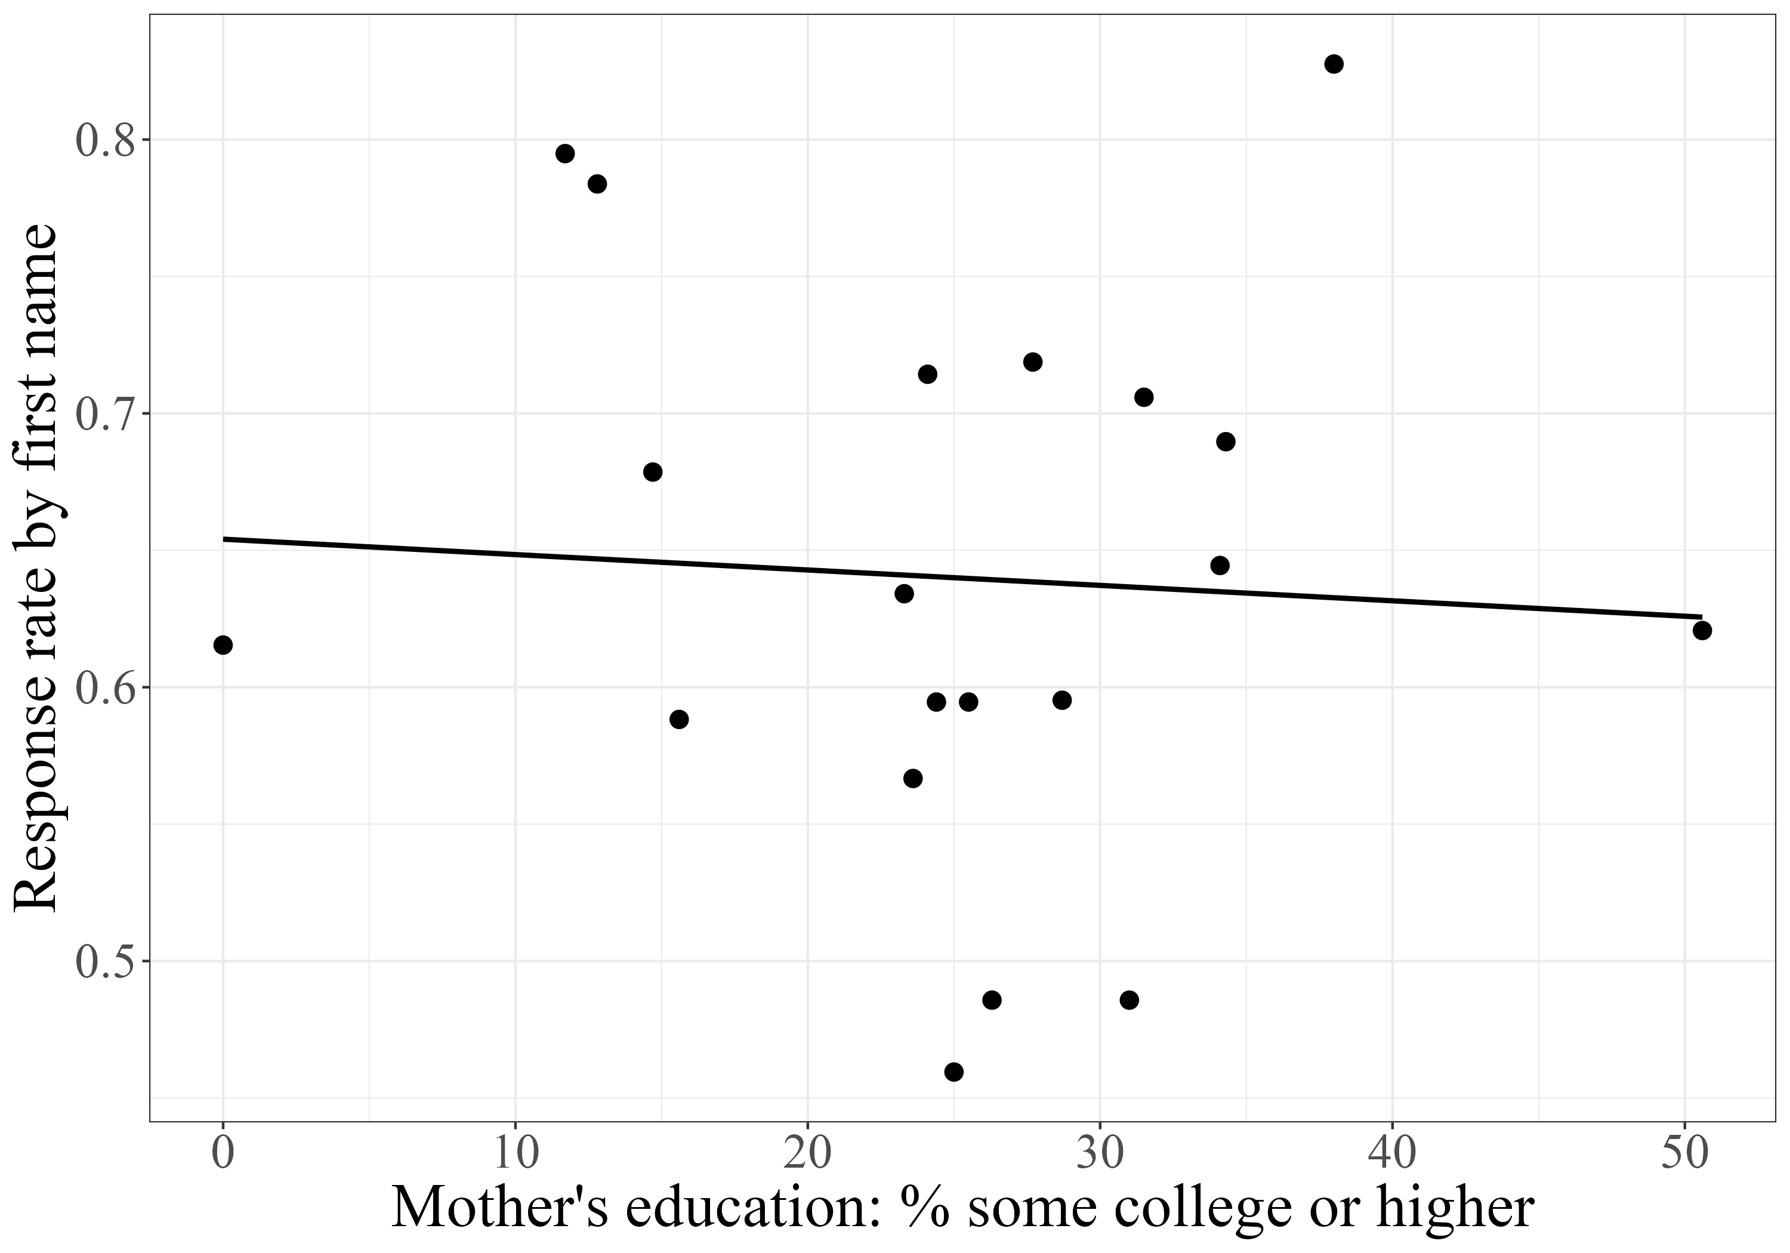
This figure shows the relationship between response rates by email sender name and mother’s educational attainment using data from Gaddis (2017a) for Black names.

Figure A.2: Response rate by proxied SES for White names

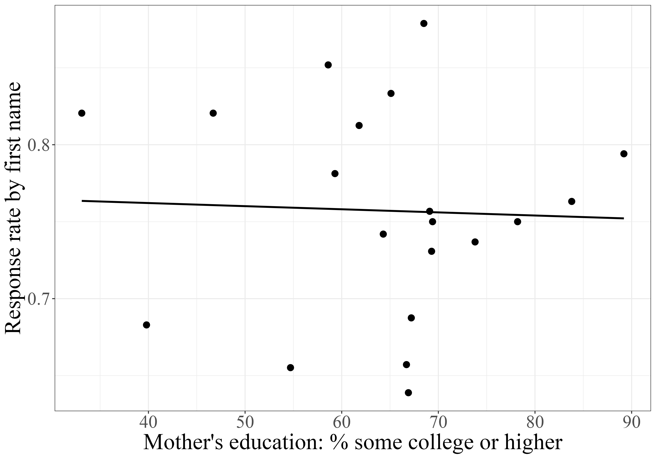
This figure shows the relationship between response rates by email sender name and mother’s educational attainment using data from Gaddis (2017a) for White names.

Figure A.3: Additional measure of the proportion of state populations represented by contacted police departments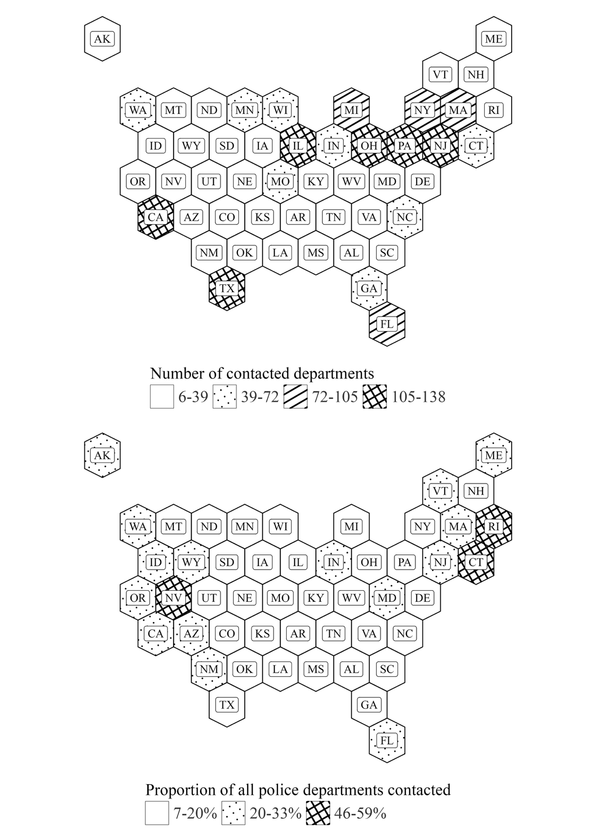

The figure shows representativeness of contacted local police departments: the number of departments contacted by state (top) and the proportion of each state’s local police departments (bottom).

Figure A.4: Population density for counties in study
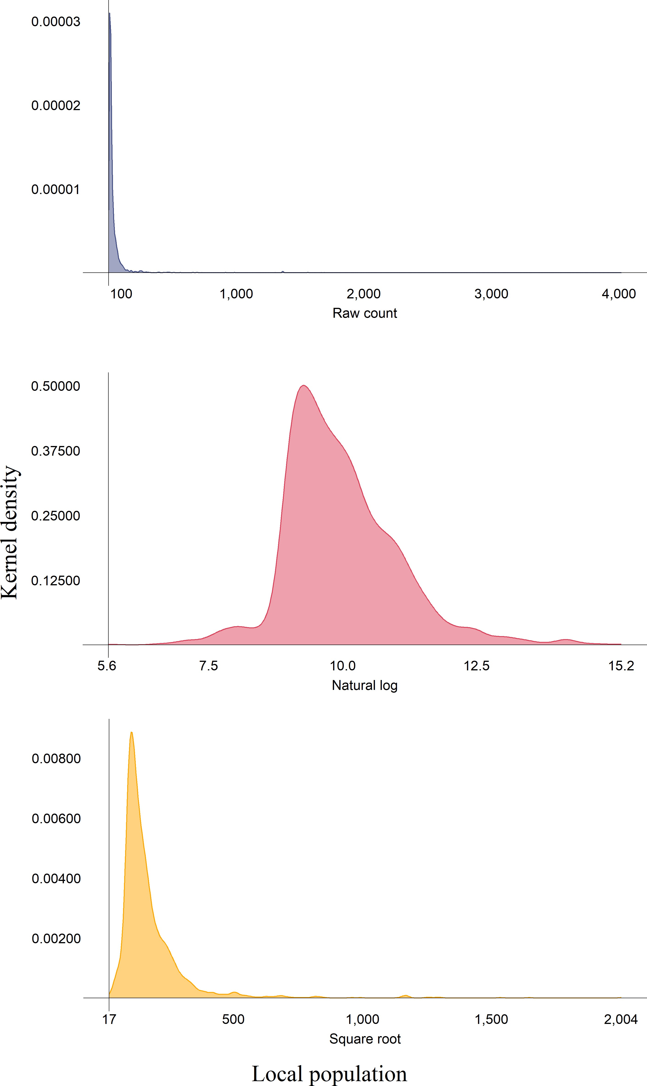

The figure shows the kernel density of local populations for (top) the raw count of the population; (middle) the natural log of the population; (bottom) the square root of the population. I use the square root of populations as weights in my analysis.

Figure A.5: Distribution of response time and word count for received responses
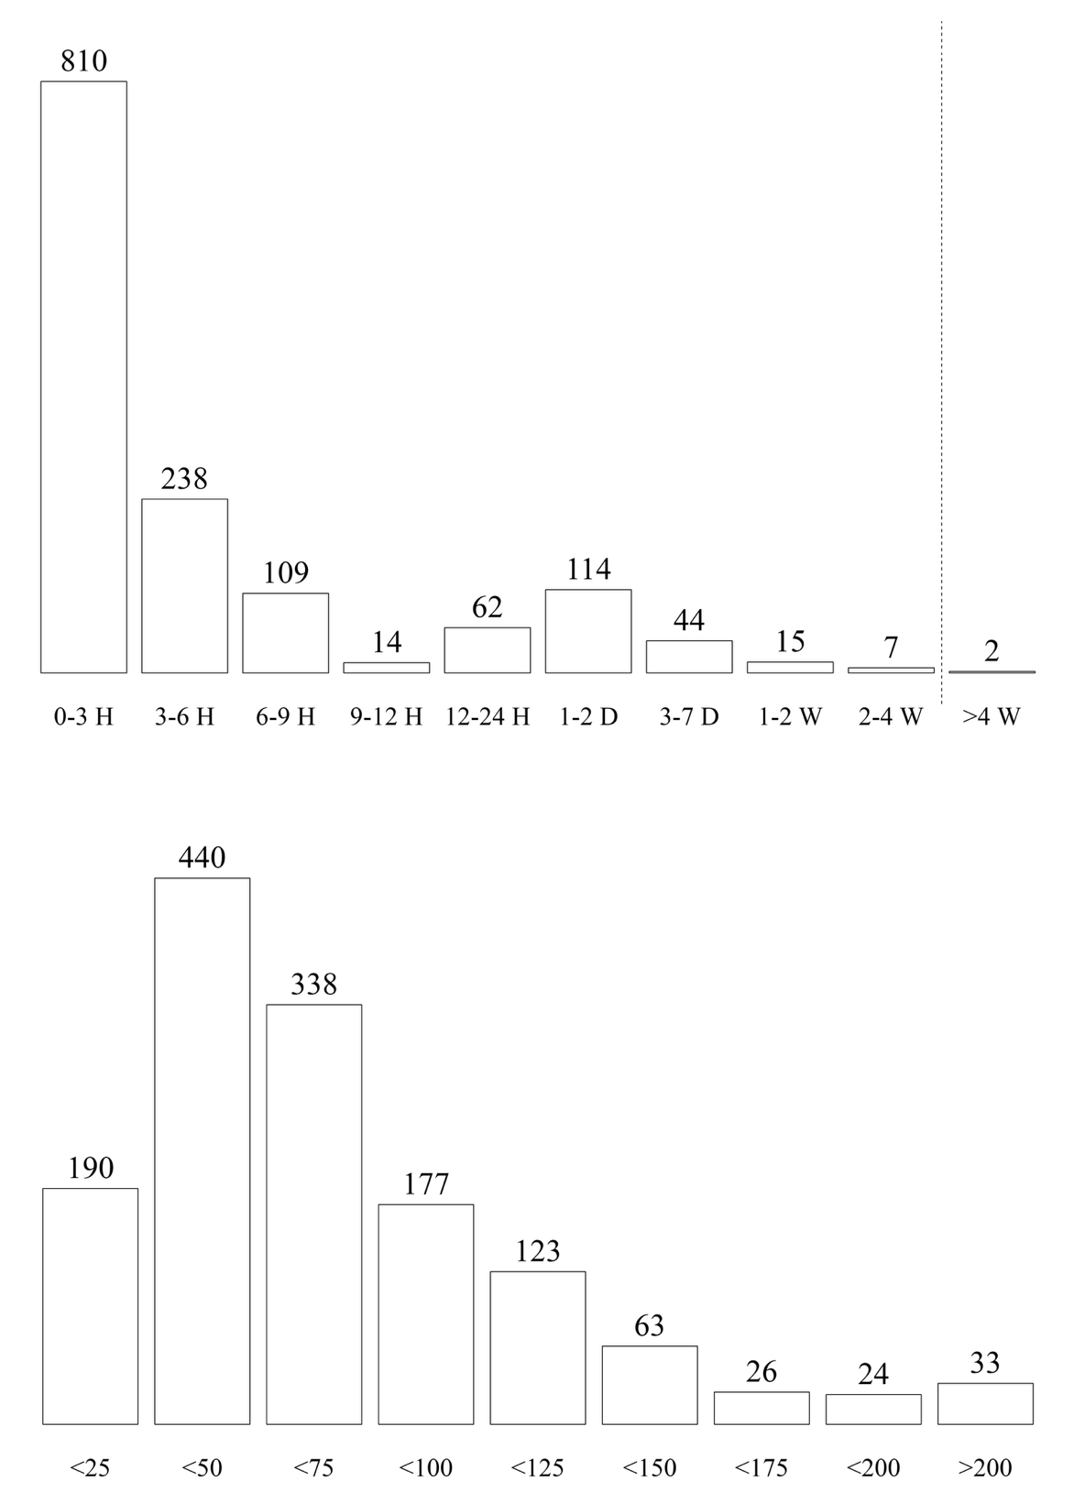
The top panel of the figure shows the count of emails binned by the duration between when the department was contacted and when the department’s response was received. Two responses were received after four weeks and were consequently considered non-responses. The bottom panel shows the count of emails binned by the number of words contained in the response. Long emails were almost exclusively pre-written details on a department’s complaint policy and procedure.

Figure A.6: Distribution of Black, Hispanic, and White population by race/ethnicity of email identity
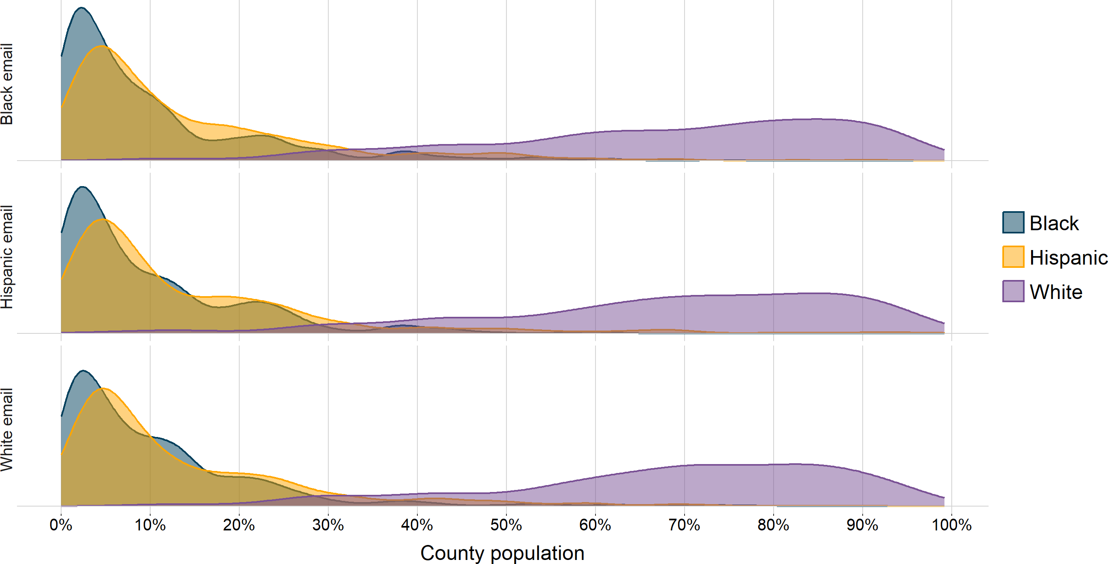

The figure shows the demographic composition (% of the population) of the counties where the contacted departments are located. The top panel displays the distribution for departments contacted by Black identities; the middle panel displays the distribution for departments contacted by White identities; and the bottom panel displays the distribution for departments contacted by White identities. The distributions are similar across identities. However, there is limited variation in the demographic composition across Black, Hispanic, and White populations.

Table A.1: Comparison of departments included and excluded from experiment

Contacted Departments Departments > 7,500 All Departments
 | Mean | Mean | Difference | Mean | Difference
Income (county-level)  Median Income all HH ($1,000s) | 66.63 | 68.07 | -1.15 (0.54) | 58.55 | 8.08 (0.39)
Median Income Black HH ($1,000s) | 47.68 | 48.02 | -0.35 (0.57) | 42.65 | 5.03 (0.5)
Median Income Hispanic HH ($1,000s) | 52.91 | 53.55 | -0.49 (0.41) | 49.88 | 3.03 (0.38)
Median Income White HH ($1,000s) | 73.62 | 75.53 | -1.48 (0.58) | 63.19 | 10.44 (0.43)
% Pop. in poverty | 12.19 | 12.19 | -0.04 (0.14) | 13.47 | -1.28 (0.12)
% Black pop. in poverty | 21.83 | 21.92 | -0.16 (0.29) | 23.76 | -1.93 (0.54)
% Hispanic pop. in poverty | 19.27 | 19.87 | -0.66 (0.23) | 21.51 | -2.24 (0.27)
% White pop. in poverty | 8.92 | 8.72 | 0.14 (0.1) | 10.68 | -1.76 (0.1)
Population  Local government pop. (thousands) | 46.63 | 46.11 | 3.15 (5.27) | 12.28 | 34.35 (2.46)
% Pop. Black (county-level) | 10.21 | 10.68 | -0.38 (0.33) | 9.09 | 1.13 (0.29)
% Pop. Hispanic (county-level) | 14.01 | 15.42 | -1.02 (0.46) | 9.69 | 4.32 (0.31)
% Pop. White (county-level) | 68.27 | 65.85 | 1.91 (0.59) | 75.59 | -7.32 (0. 45)
Department size (# of employees)  Total employees | 117.46 | 111.13 | 12.49 (25.24) | 32.67 | 84.79 (12.19)
Total officers | 93.66 | 85.44 | 13.12 (18.07) | 25.61 | 68.05 (8.73)
Total civilian employees | 23.80 | 25.69 | -0.62 (7.5) | 7.07 | 16.74 (3.62)
This table compares mean values of geographic and police departmental characteristics between police departments I contacted and police departments I did not contact. Mean indicates the average value for departments, and Difference indicates the differential from the mean for departments contacted. The first column indicates the mean values for contacted departments. Columns 2 and 3 compare
police departments in the U.S. with local populations ≥ 7,500 (n = 4,624) to contacted departments. Columns 4 and 5 compare all police
departments (n = 13,734) in the U.S. to contacted departments. Standard-errors in parentheses. Signif. Codes: ***: 0.01, **: 0.05, *:
0.1

Table A.2: Comparison of departments missing public email addresses

Missing Email Departments All Departments Departments > 7,500 Searched Departments
 | Mean |  | Mean | Difference |  | Mean | Difference |  | Mean | Difference
Income (county-level)  Median income all HH ($1,000s) | 63.33 |  | 59.73 | 3.61 (1.02) |  | 67.83 | -4.38 (1.14) |  | 66.63 | -3.3 (1.12)
Median income Black HH ($1,000s) | 45.47 |  | 43.50 | 1.97 (1.29) |  | 48.00 | -2.32 (1.21) |  | 47.68 | -2.21 (1.28)
Median income Hispanic HH ($1,000s) | 51.08 |  | 50.37 | 0.71 (0.97) |  | 53.48 | -2.48 (0.88) |  | 52.91 | -1.83 (0.89)
Median income White HH ($1,000s) | 70.43 |  | 64.68 | 5.74 (1.11) |  | 75.15 | -4.5 (1.23) |  | 73.62 | -3.19 (1.23)
% Pop. in poverty | 12.74 |  | 13.28 | -0.54 (0.31) |  | 12.14 | 0.6 (0.29) |  | 12.19 | 0.55 (0.3)
% Black pop. in poverty | 23.78 |  | 23.45 | 0.33 (1.38) |  | 21.73 | 1.97 (0.62) |  | 21.83 | 1.95 (0.66)
% Hispanic pop. in poverty | 20.98 |  | 21.17 | -0.19 (0.68) |  | 19.49 | 1.5 (0.48) |  | 19.27 | 1.71 (0.49)
% White pop. in poverty | 9.43 |  | 10.43 | -1.01 (0.26) |  | 8.74 | 0.64 (0.22) |  | 8.92 | 0.5 (0.23)
Population
Local population (1000s) | 36.94 | 17.19 |  | 19.75 (6.33) | 48.04 |  | -9.63 (11.15) | 46.63 |  | -9.69 (9.58)
Pop. % Black (county-level) | 10.93 | 9.23 |  | 1.7 (0.75) | 10.48 |  | 0.6 (0.71) | 10.21 |  | 0.72 (0.72)
Pop. % Hispanic (county-level) | 11.78 | 10.33 |  | 1.46 (0.79) | 15.16 |  | -3.16 (0.97) | 14.01 |  | -2.23 (0.92)
Pop. % White (county-level) | 70.51 | 74.54 |  | -4.02 (1.16) | 66.47 |  | 3.55 (1.25) | 68.27 |  | 2.25 (1.24)
Department size (# of employees)  Total employees | 80.71 | 46.04 |  | 34.67 (30.93) | 118.47 |  | -34.91 (53.15) | 117.09 |  | -36.38 (31.99)
Total officers | 63.56 | 36.35 |  | 27.21 (22.17) | 92.62 |  | -26.86 (38.06) | 93.37 |  | -29.81 (26.86)
Total civilian employees | 17.15 | 9.69 |  | 7.46 (9.17) | 25.85 |  | -8.04 (15.79) | 23.72 |  | -6.57 (5.91)
Census region  % Midwest | 31.67 | 31.80 |  | -0.13 | 27.53 |  | 4.14 | 30.07 |  | 1.6
% Northeast | 31.32 | 23.99 |  | 7.33 | 27.85 |  | 3.47 | 26.95 |  | 4.37
% South | 24.56 | 32.40 |  | -7.84 | 26.67 |  | -2.11 | 26.95 |  | -2.39
% West | 12.46 | 11.81 |  | 0.65 | 17.95 |  | -5.49 | 16.03 |  | -3.57
This table compares mean values of geographic and police departmental characteristics to the police departments for which I could not find a publicly available email address. There are 281 “missing email” departments. Mean indicates the average value for the specified sample of departments, and Difference indicates the difference from the mean for departments without email addresses. The first column reports the mean values for departments missing an email address. Columns
2-3 report statistics (mean and difference) for all police departments (n = 13,734) in the United States. The Columns 4-5 report statistics (mean and difference) for police departments in the U.S. with local populations ≥ 7,500 (n = 4,624). The last two columns report statistics (mean and difference) for police departments included in my original sample (n = 2,415).

Table A.3: Email addresses used

 | White |  | Black |  | Hispanic
Olson | olson2292@ | Washington | washingtonn.1962@ | Hernandez | h3rnand3z.1973@
Schmidt | schmidt.04513@ | Jefferson | jeffersn78@ | Gonzalez | gonzzalezzz.1994@
Meyer | meyerrr.1982@ | Jackson | jacksonnn.1990@ | Rodriguez | the.rodriguezzz1992@
Snyder | snyderrr.1992@ | Joseph | joe.seph1952@ | Ramirez | m.ramirezz.1986@
Hansen | hans3n.1972@ | Williams | the.williams.1956@ | Martinez | martin3z.1978@
Larson | larsonn.1952@ | Banks | banksss.1991@ | Lopez | lopezjr.0621@
The table shows the email accounts I created for the fictional identities in the correspondence study. I made six accounts for each of the three race/ethnicity identities (Black, Hispanic, white).

Table A.4: First names used in study

White Male | White Female | Black Male | Black Female | Hispanic Male | Hispanic Female
Hunter | Katelyn | DaShawn | Tanisha | Alejandro | Mariana
Jake | Claire | Tremayne | Lakisha | Pedro | Guadalupe
Seth | Laurie | Jamal | Janae | Santiago | Isabella
Zachary | Stephanie | DaQuan | Tamika | Luis | Esmeralda
Todd | Abigail | DeAndre | Latoya | Esteban | Jimena
Matthew | Megan | Tyrone | Tyra | Pablo | Alejandra
Logan | Kristen | Keyshawn | Ebony | Rodrigo | Valeria
Ryan | Emily | Denzel | Denisha | Felipe | Lucia
Dustin | Sarah | Latrell | Taniya | Juan | Florencia
Brett | Molly | Jayvon | Heaven | Fernando | Juanita
The table shows the first names used to create the fictional identities in the correspondence study. The names are chosen to be distinctive regarding race/ethnicity and gender while also commonly occurring. Each of the six identities (Black man, Black woman, Hispanic man, Hispanic woman, white man, and white woman) uses ten unique first names.

Table A.5: Balance Table

Putative Identity

 | (1) | (2) | (3) | (4) | (5) | (6)
 | White man | White woman | Hispanic man | Hispanic woman | Black man | Black woman
 | (n = 359) | (n = 352) | (n = 350) | (n = 361) | (n = 358) | (n = 354)
 | (Mean) |  |  | Differential
Income (county-level)  Median Income all HH ($1,000s) | $66.64 | -0.02 (1.33) | 0.08 (1.33) | -0.52 (1.32) | 0.35 (1.32) | -0.09 (1.32)
Median Income Black HH ($1,000s) | $47.66 | -1.86 (1.47) | 0.54 (1.48) | -0.14 (1.46) | 0.67 (1.46) | 0.8 (1.47)
Median Income Hispanic HH ($1,000s) | $52.99 | -0.49 (1.04) | -0.14 (1.04) | -0.49 (1.03) | -0.08 (1.03) | 0.66 (1.04)
Median Income White HH ($1,000s) | $73.30 | 0.91 (1.45) | 0.63 (1.45) | -0.06 (1.44) | 0.29 (1.44) | 0.31 (1.45)
% Pop. in poverty | 12.05 | 0.36 (0.36) | 0.37 (0.36) | 0.09 (0.35) | -0.14 (0.36) | 0.18 (0.36)
% Black pop. in poverty | 21.80 | 0.86 (0.76) | -0.11 (0.77) | -0.24 (0.76) | -0.65 (0.76) | 0.29 (0.76)
% Hispanic pop. in poverty | 19.32 | -0.13 (0.56) | 0.16 (0.57) | 0.04 (0.56) | 0.09 (0.56) | -0.25 (0.56)
% White pop. in poverty | 8.92 | 0.07 (0.27) | 0.08 (0.27) | -0.05 (0.27) | -0.16 (0.27) | 0.03 (0.27)
Population  Local government pop. (1000s) | 49.40 | 4.04 (13.06) | -1.2 (13.07) | 13.02 (12.97) | -7.73 (13) | 1.01 (13.04)
Pop. % Black (county-level) | 9.79 | 1.46 (0.85) | 0.09 (0.85) | 0.54 (0.84) | -0.03 (0.84) | 0.73 (0.84)
Pop. % Hispanic (county-level) | 13.90 | -0.25 (1.11) | 0.69 (1.11) | 0.33 (1.10) | 0.13 (1.11) | 0.29 (1.11)
Pop. % White (county-level) | 69.10 | -1.83 (1.48) | -1.28 (1.48) | -1.16 (1.47) | -0.06 (1.48) | -1.51 (1.48)
Department size (# of employees)  Total employees | 128 | 0 (43) | -13 (43) | 48 (43) | -22 (43) | -8 (43)
Total officers | 104 | -1 (36) | -12 (36) | 40 (36) | -22 (36) | -9 (36)
Total civilian employees | 24 | 0 (8) | -1 (8) | 8 (8) | 0 (8) | 1 (8)

This table compares mean values of geographic and police departmental characteristics across the different identities. For each variable being compared, Column 1 displays the mean value of the variables for departments that received emails from White male identities. Columns 2 through 6 show the difference between the value in Column 1 and the mean value for the other five identities. For example, the average county median income for departments that received emails from White male identities is $66,700. In comparison, the average county median income for departments that received emails from Hispanic woman identities is $520 lower, with a standard error of $1,320. The absence of strongly statistically significant differences across the table reflects that the variables are not correlated with treatment assignment. Standard-errors in parentheses.

Table A.6: Response rate differences by officer race and ethnicity

 | (1) |  |  | (2) |  |  | (3) |  |  | (4)
 | Est. | p |  | Est. | p |  | Est. | p |  | Est. | p
Black | -0.134 (0.064) | 0.065 |  | -0.192 (0.067) | 0.019 |  | -0.180 (0.208) | 0.409 |  | -0.234 (0.244) | 0.363
Dept % Black | -0.127 (0.170) | 0.012 |  | -0.349 (0.205) | 0.124
Hispanic | -0.062 (0.062) | 0.340 |  | -0.048 (0.063) | 0.463 |  | -0.152 (0.150) | 0.337 |  | -0.242 (0.134) | 0.103
Dept % Hispanic | -0.306 (0.138) | 0.054 |  | -0.191 (0.186) | 0.331
Black:Dept % Black | 0.493 (0.509) | 0.359 |  | 0.644 (0.683) | 0.370
Hispanic:Dept % Hispanic | -0.181 (0.270) | 0.519 |  | -0.410 (0.246) | 0.13
Dept % White |  |  |  |  |  |  | 0.245 (0.153) | 0.145 |  | 0.154 (0.151) | 0.335
Black:Dept % White |  |  |  |  |  |  | 0.093 (0.266) | 0.734 |  | 0.111 (0.308) | 0.727
Dept % White:Hispanic |  |  |  |  |  |  | 0.078 (0.182) | 0.679 |  | 0.183 (0.165) | 0.297
LEMAS survey | Both |  |  | 2020 |  |  | Both |  |  | 2020
Num.Obs. | 728 |  |  | 495 |  |  | 728 |  |  | 495
Results show differences in response rates by race and ethnicity, interacted with the racial distribution of the department. Data is drawn from LEMAS. Models 1 and 3 include data from the 2016 and 2020 LEMAS. Models 3 and 4 restrict the sample to the 2020 LEMAS data. For each model, I report the overall response rate and the response rate for white-sounding names, which serve as the control group. Coefficient estimates are presented with standard errors in parentheses and p-values listed separately. All models include state and week fixed effects. Standard errors are clustered by state and week.

A.7: Response rates by Census region
 | Northeast |  |  | South |  |  | Midwest |  |  | West
 | Est. | p |  | Est. | p |  | Est. | p |  | Est. | p
Black | -0.1044 (0.0407) | 0.030 |  | -0.1054 (0.0722) | 0.179 |  | -0.1398 (0.0532) | 0.027 |  | -0.0842 (0.0592) | 0.189
Hispanic | -0.1279 (0.0479) | 0.026 |  | -0.0944 (0.0312) | 0.014 |  | -0.1183 (0.0375) | 0.017 |  | -0.1155 (0.0648) | 0.108
Women | 0.0621 (0.0608) | 0.334 |  | -0.0020 (0.0354) | 0.956 |  | 0.0352 (0.0433) | 0.438 |  | -0.0093 (0.0744) | 0.903
White | 0.747 |  |  | 0.717 |  |  | 0.790 |  |  | 0.775
Man | 0.633 |  |  | 0.643 |  |  | 0.686 |  |  | 0.707
Num.Obs. | 547 |  |  | 572 |  |  | 621 |  |  | 346
This table describes response rates for aggregated identities across Census regions. To estimate each model, I subset the data using a department’s state.
The response rates for the comparison groups (White and male) can be found at the bottom of the table.

Table A.8: The effect of email sign-off on response rates

 | Est. | p
Sign-off | 0.0078 (0.0294) | 0.7978
Black | −0.1363 (0.0336) | 0.0028
Hispanic | −0.1180 (0.0252) | 0.0011
Women | 0.0326 (0.0285) | 0.2818
Sign-off:Black | 0.0520 (0.0577) | 0.3905
Sign-off:Hispanic | 0.0094 (0.0364) | 0.8016
Sign-off:Women | −0.0191 (0.0363) | 0.6111
Num.Obs. | 2086
This table reports the effect of the email sign-off on response rates. Sign-offs vary between “Thank you!” and “Sincerely,”. The sign-off variable is a binary indicator equal to one if the sign-off was “Thank you!” for an email. Results suggest that police departments did not respond differently between the two sign-offs.

Table A.9: Email identities’ implied age summary

 | Black | Hispanic | White
Statistic
Mean | 50.5 | 37.3 | 47.4
Median | 60 | 36 | 40
Maximum | 70 | 49 | 70
Minimum | 31 | 28 | 30
Observations | 698 | 573 | 458
This table summarises the implied ages of the identities in this study. The distribution of ages across race/ethnicity groups varies slightly. Hispanic identities are somewhat younger than Black and White identities. The number of observations differs across identities because two White usernames and one Hispanic username did not include implied birth years.

Table A.10: The effect of implied age of email sender on response rates
 | Est. | p
Age | −0.0044 (0.0028) | 0.1507
Black | −0.3043 (0.1283) | 0.0418
Hispanic | −0.4700 (0.1379) | 0.0078
Women | −0.0153 (0.0740) | 0.8410
Age:Black | 0.0045 (0.0025) | 0.1064
Age:Hispanic | 0.0085 (0.0030) | 0.0187
Age:Women | 0.0011 (0.0015) | 0.4610
Num.Obs. | 1729
This table reports the effect of the implied age on response rates. Results reflect the interaction of an identity’s implied race/ethnicity, gender, and age. Age is a continuous variable measured in years and signaled via the username of the email accounts used in the study. Three usernames (Olson, Schmidt, and Lopez) did not include implied birth years, so I excluded the associated observations from this analysis. Results suggest that police are more likely to respond to "older" identities.
 |  |  |  | (2)
 | Est. | p |  | Est. | p
Black | 0.4142 (4.1030) | 0.9218 |  | 6.1352 (5.4608) | 0.2903
Hispanic | 0.2401 (1.0170) | 0.8186 |  | -2.2375 (3.9302) | 0.5831
Women | -4.7601 (3.4463) | 0.2005 |  | -1.9822 (3.8484) | 0.6189
Num.Obs. | 1412 |  |  | 1415

Table A.11: Response time and word count of response measured across identities

This table reports on the quality of police response emails. I use the number of words in a response, and the time it took departments to respond as a cursory measure of response quality. Model 1 examines whether the response length is correlated with identities and is measured in the number of words. Model 2 examines whether the departments responded more or less quickly to an inquiry according to the identity and is measured in hours after I contacted a police department.

Table A.12: Response Rate Differences by Race and Gender (only departments serving >7,500)

 | (1) |  |  | (2)
 | Est. | p |  | Est. | p
Black | -0.1024 (0.0298) | 0.0075 |  | -0.1095 (0.0291) | 0.0044
Hispanic | -0.1004 (0.0246) | 0.0028 |  | -0.1154 (0.0179) | 0.0001
Women | 0.0204 (0.0301) | 0.4863 |  | 0.0022 (0.0300) | 0.9435
Weights | Standard OLS |  |  | Sqrt. local pop
Reference mean | White: 0.752
 | Men: 0.667
Num.Obs. | 2086 |  |  | 2086
I re-estimate Table 3 using data that includes only departments serving 7,500 residents or more. The sample size is reduced from 2,086 to 1,963 observations. Compared to the full sample, the magnitudes of the estimates are slightly smaller but still large and statistically significant.

Vignette studies, also known as factorial survey experiments, present respondents with hypothetical scenarios (vignettes) in which key variables are systematically varied by the researcher. This design allows researchers to causally identify how specific factors influence perceptions and decision making. In law enforcement research, respondents are often law enforcement officers. However, studies can also survey civilians as a way to examine how police behavior effects public perceptions of law enforcement.
The “blue wall of silence” refers to an informal code of silence regarding reporting on peers’ misconduct or errors among law enforcement agents.
To the extent that the present study replicates Giulietti et al. (2019), confirming or refining their findings is valuable, as this remains only the second correspondence study to include law enforcement agencies.
I exclude state police, sheriffs, and special police agencies (e.g., airport, transit, or university police)
I expand on the selection process and motivate my decision to focus on local police departments in Section A.1.1. of the Appendix.
By chance, none of Hawaii’s five local departments were selected in the sampling process.
The police departments selected for this study are associated with governments smaller than counties. However, it is unclear exactly which population would be relevant for each department. If I use data for a geography that is too narrowly specified (e.g., the zip code of the department), I risk mischaracterizing a department’s local context. Accordingly, I use county-level data to characterize the economic and racial composition of a department’s locality.
Results from the balance test are reported in Table A.5 in the Appendix.
Please refer to section 1.7. of the Appendix for a detailed explanation of the treatment assignment.
See section A2 of the Appendix for more details.
The distribution of response times can be seen in Figure A.5 in the Appendix.
Population weights are assigned by the local government population, not the county in which a department operates. Section A.2.2 in the Appendix expands on the weighting schemes.
The values are balanced across treatments, but the minimal variance leads to noisy estimates. Figure A.6 illustrates the distributions of population breakdowns.
LEMAS is a survey conducted every four years that solicits information from a representative sample of LEA across the United States. Because the LEMAS uses a sample, not every agency is contacted with each iteration. Additionally, the survey is optional, and not all agencies choose to respond. Matching the departments from the 2020 sample that completed the survey with the departments in the present study results in only ≈ 500 observations. Including the 2016 LEMAS, increases the number of observations to 754.
I also examine the relationship between response rates and officer composition. Results can be found in Table A6.
Fryer and Levitt (2004) find that, unlike African Americans, lower-SES Hispanic mothers are not markedly more like to give distinctively Hispanic names. However, in the present study I find similar levels of discrimination against Black and Hispanic names.
Please see Appendix section A.3.2.
I decided to include multiple email addresses from Dallas because the Dallas Police Department has several distinct stations with unique contact information. Rather than randomly selecting a single station, I used Dallas as a small test to measure the likelihood of interdepartmental communication regarding the emails I sent. The results suggest that the stations did not communicate with each other about the emails. Of course, Dallas is a particularly large department, so the outcome of, for example, contacting a smaller department multiple times remains unclear.

